**2. ZODIAC**

|  |
| --- |
| **BRITANNICA ZODIAC SCRILL DOWNING** |
| [♈ Aries (Ram): March 21–April 19](https://www.britannica.com/place/Aries) |
| [♉ Taurus (Bull): April 20–May 20](https://www.britannica.com/place/Taurus) |
| [♊ Gemini (Twins): May 21–June 21](https://www.britannica.com/place/Gemini-constellation-and-astrological-sign) |
| [♋ Cancer (Crab): June 22–July 22](https://www.britannica.com/place/Cancer-constellation) |
| [♌ Leo (Lion): July 23–August 22](https://www.britannica.com/place/Leo-constellation) |
| [♍ Virgo (Virgin): August 23–September 22](https://www.britannica.com/place/Virgo) |
| [♎ Libra (Balance): September 23–October 23](https://www.britannica.com/place/Libra-constellation) |
| [♏ Scorpius (Scorpion): October 24–November 21](https://www.britannica.com/place/Scorpius) |
| [♐ Sagittarius (Archer): November 22–December 21](https://www.britannica.com/place/Sagittarius-constellation) |
| [♑ Capricornus (Goat): December 22–January 19](https://www.britannica.com/place/Capricornus) |
| [♒ Aquarius (Water Bearer): January 20–February 18](https://www.britannica.com/place/Aquarius-astronomy) |
| [♓ Pisces (Fish): February 19–March 20](https://www.britannica.com/place/Pisces) |

|  |  |  |
| --- | --- | --- |
| **ZODIAC SIGNS** | **Character Accuracy**: 97.3 | **gns as k-pop female idols** |
| **ARIES** | Chu, Che, Cho, La, Li, Lu, Le, Lo, A | Mina (TWICE) |
| **TAURUS** | E, V, Ai, o, Vaa, Vi, Vu, Ve, Vo | Junghwa (EXID) |
| **GEMINI** | Ka, Ki, Ku, Gh, Chh, Ke, Ko, Ha | Eunha (GFRIEND) |
| **CANCER** | Hi, Hu, He, Ho, Da, Di, Du, De, Do | Lia (ITZY) |
| **LEO** | M, Mi, Mu, Me, Mo, Ta, Ti, Tu, Te | Sohee (Rocket Punch] |
| **VIRGO** | To, Pa, Pi, Pe, sha, Thha, Pe, Po | Joy (Red Velvet) |
| **LIBRA** | Ra, Ri, Ru, Re, Ro, Taa, Ti, Tu, Te | Heeji (LOONA) |
| **SCORPIO** | To, N, Ni, Nu, Ne, No, Ya, Yi, Yu | MOMO (TWICE) |
| **SAGITTARIUS** | Ye, Yo, Bha, Bhi, Bhu, Dha, Pha(F), Dhha, Bhe | Yeonhee (Rocket Punch) |
| **CAPRICORN** | Bho, Ja, li, Khi, Khu(Khoo), Khe, Kho, Ga, Gi | Jisoo (BLACKPINK) |
| **AQUARIUS** | Gu (Goo), Ge, Go, Sa, Si, Soo (Su), Se, So, Da (The) | Seulgi (Red Velvet) |
| **PISCES** | Di, Du, Thha, Jha, Jya, De, Do, ch, Chi | Taeyeon (SNSD) |

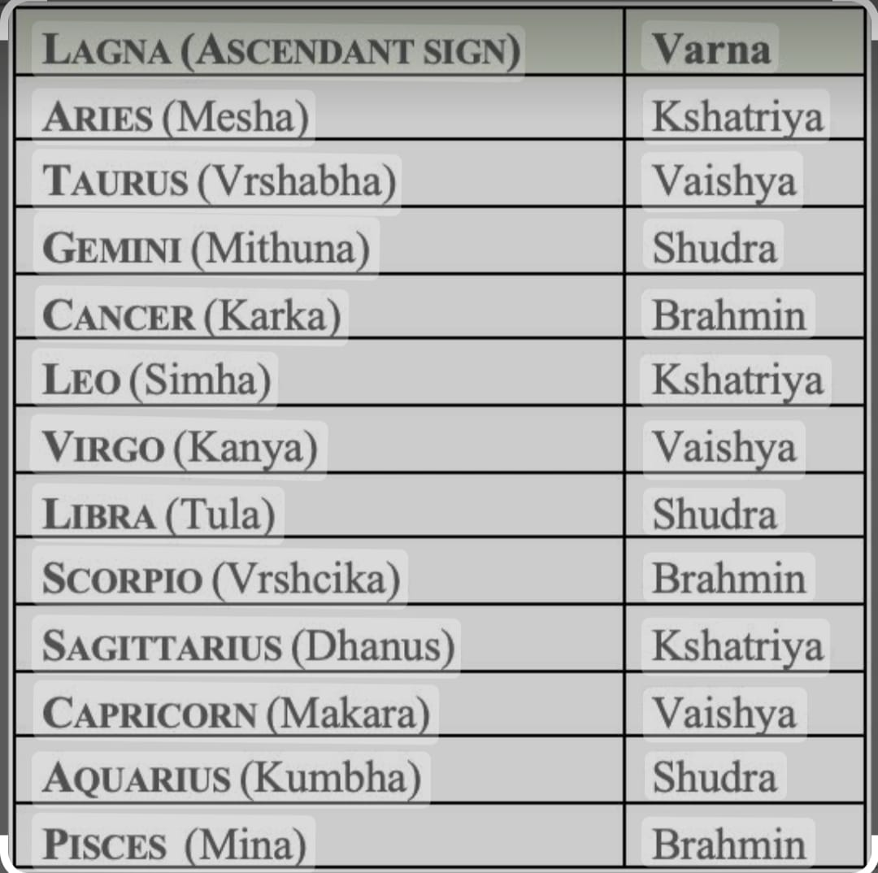

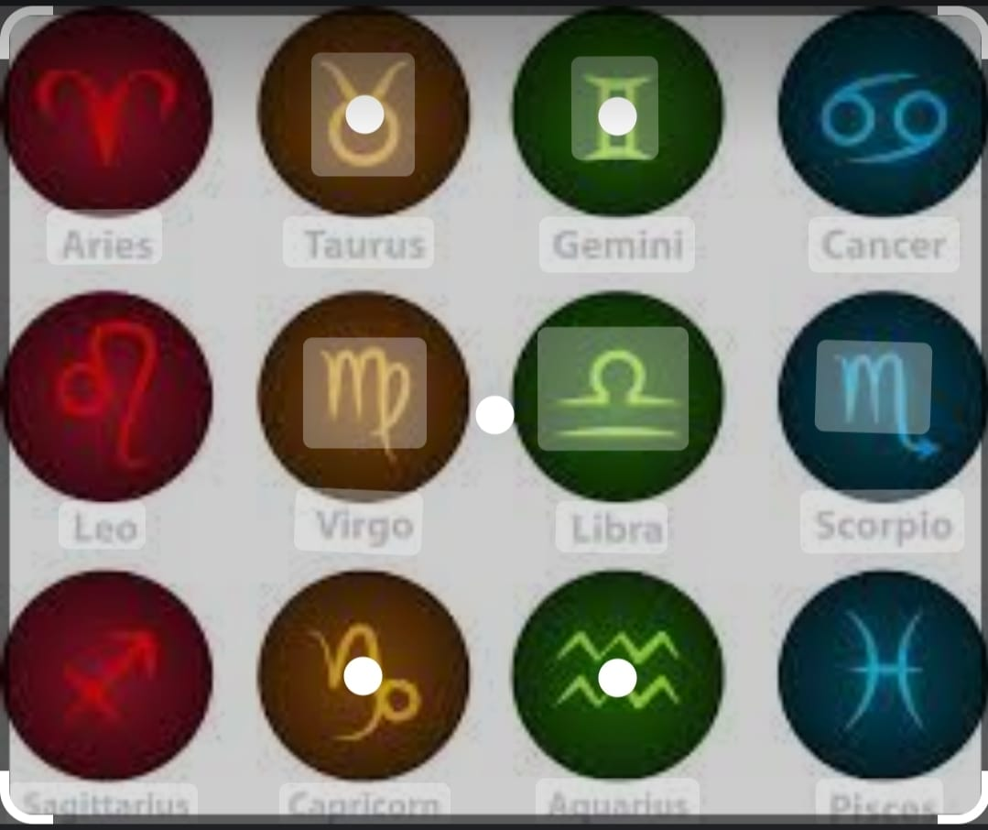

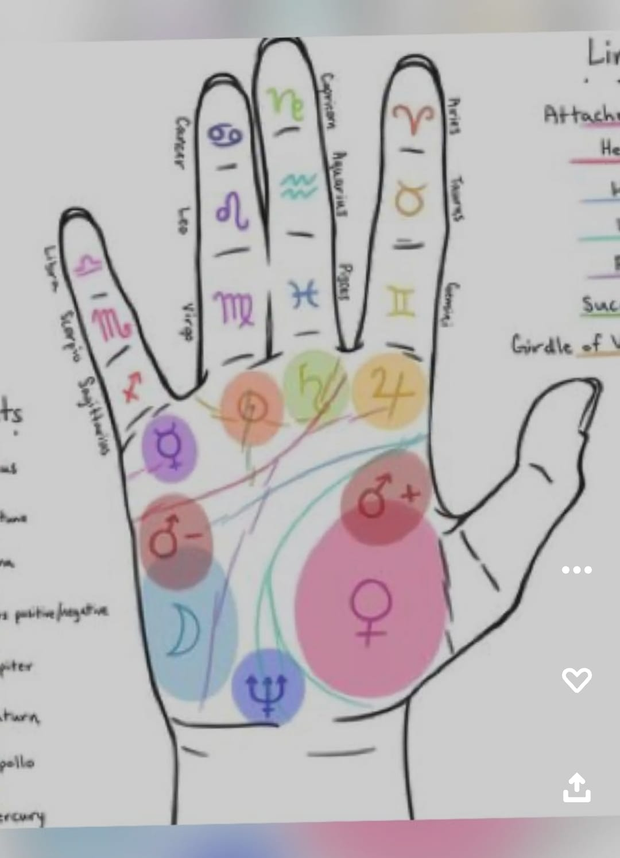

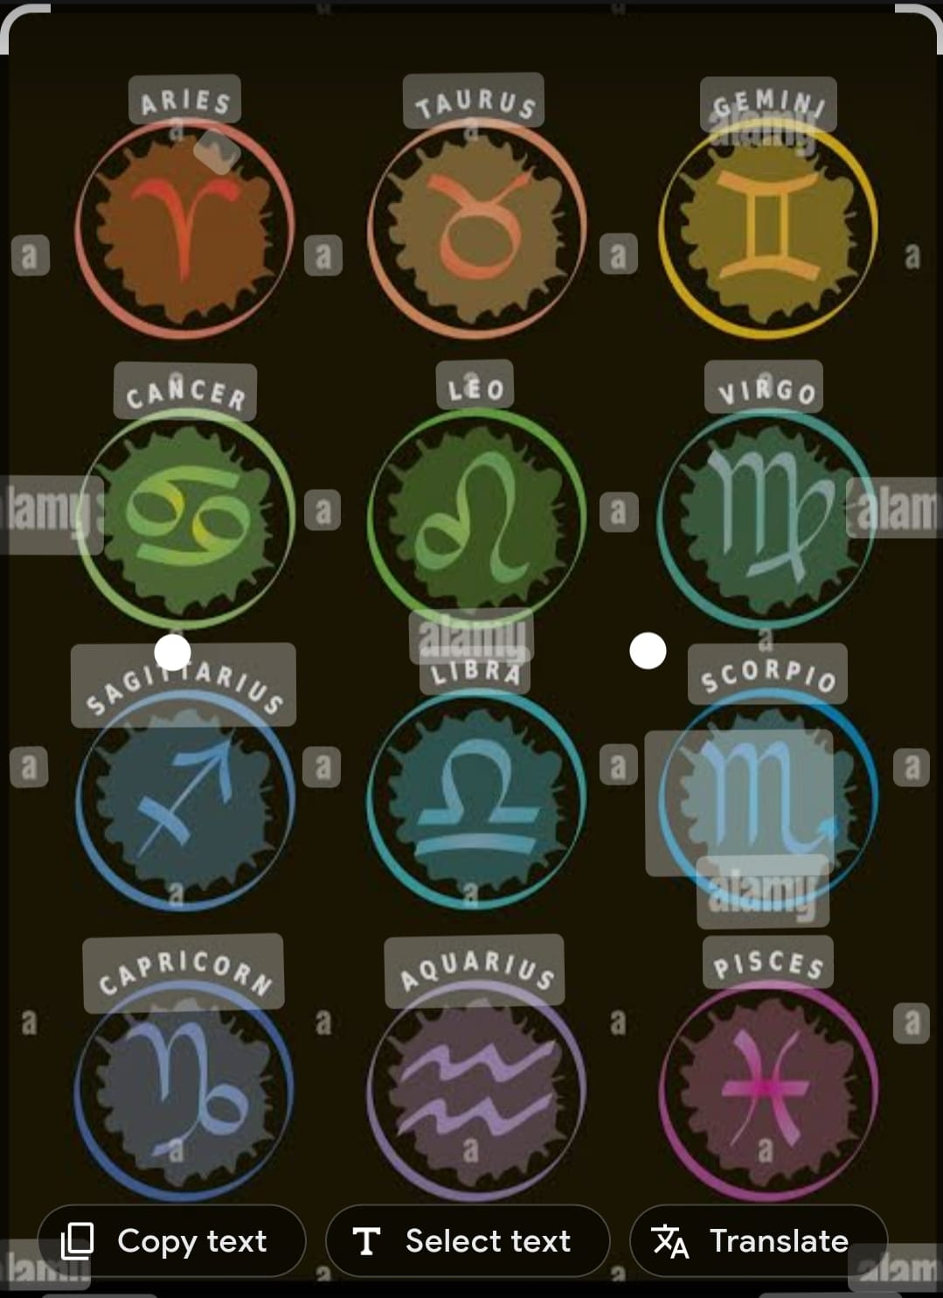

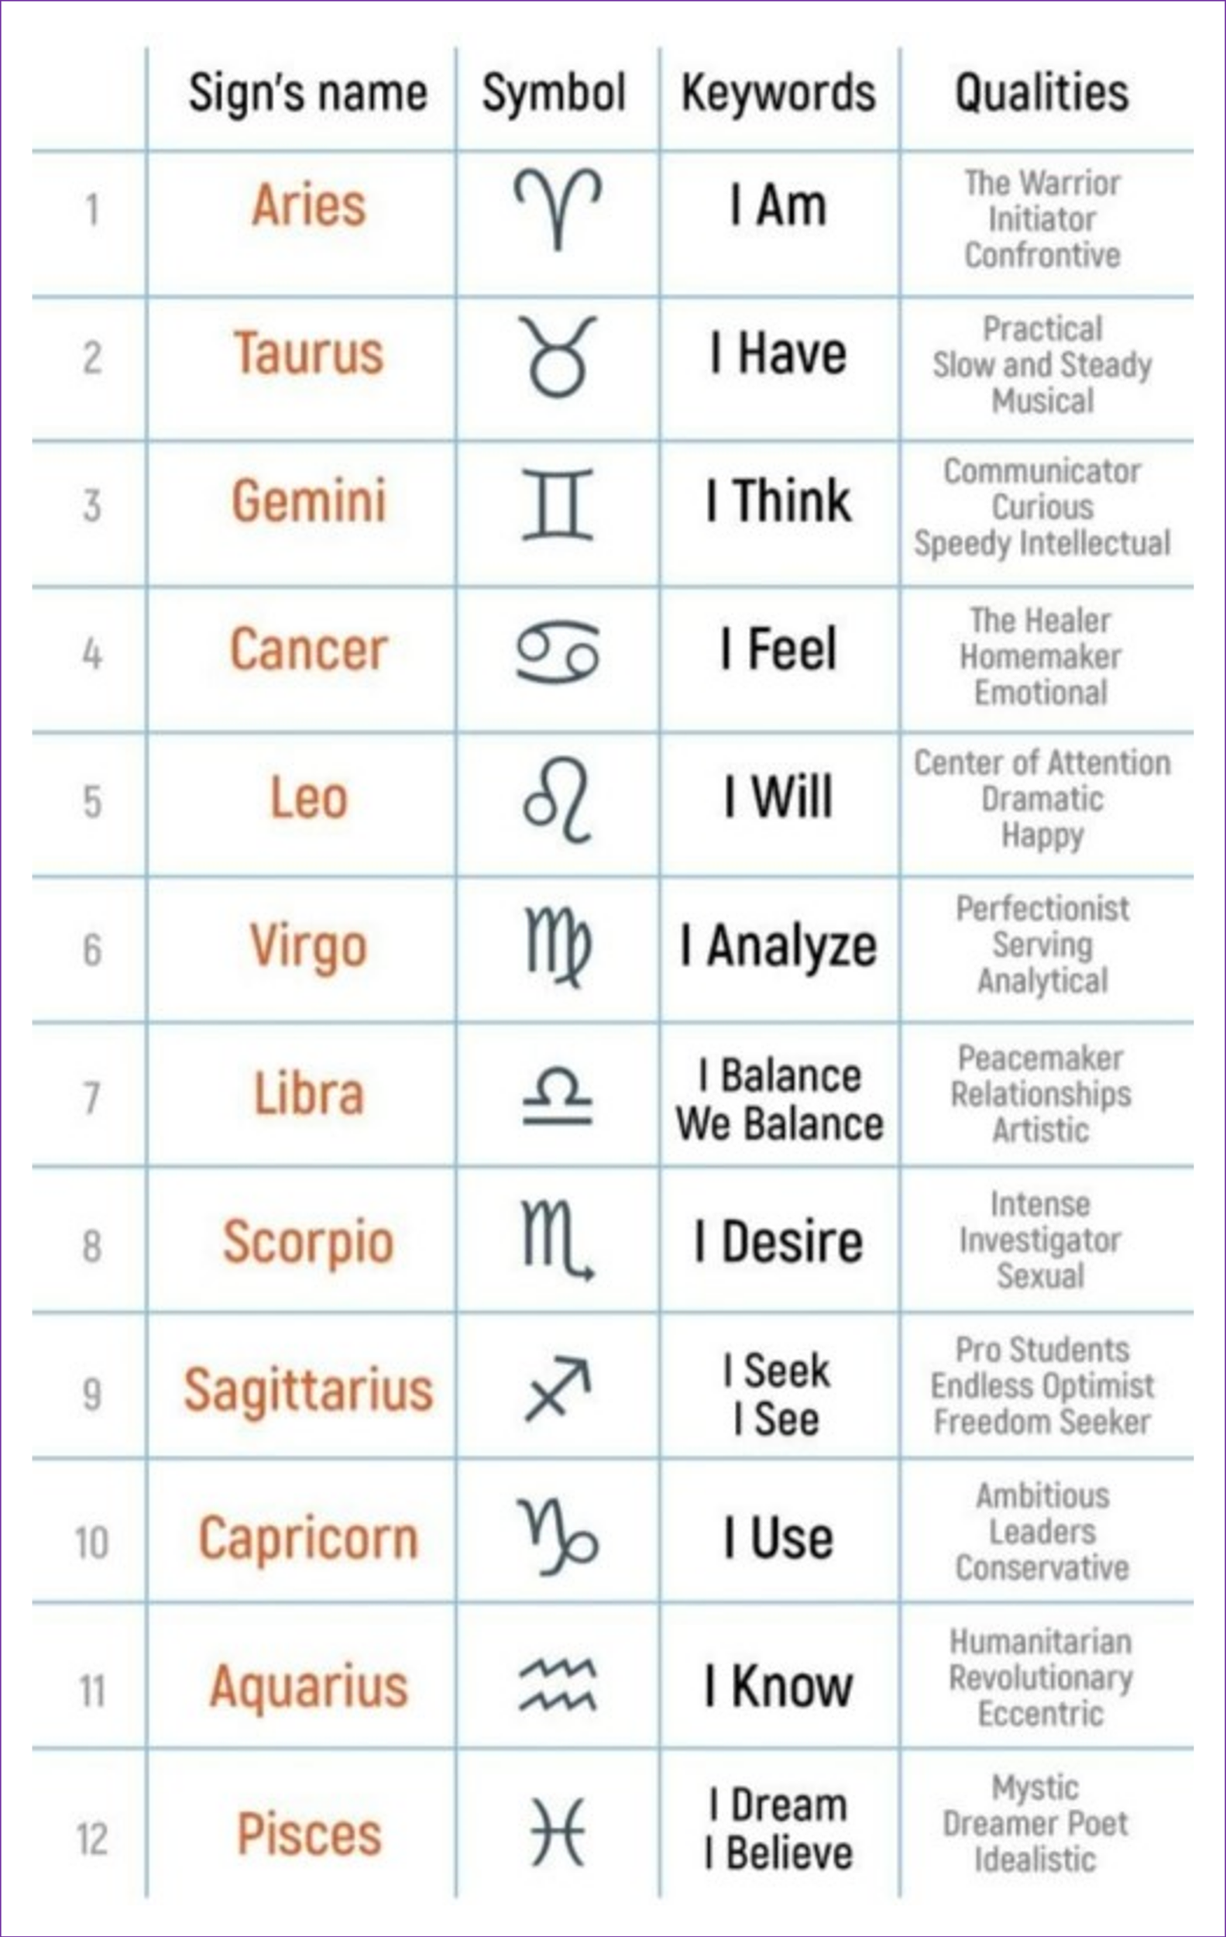

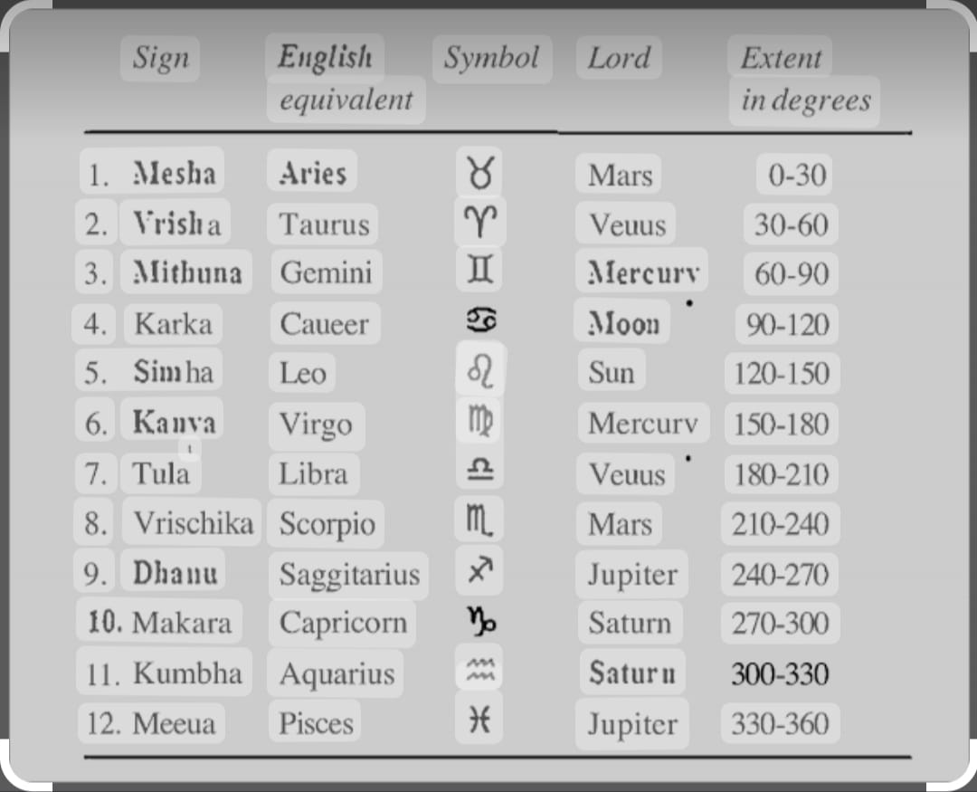

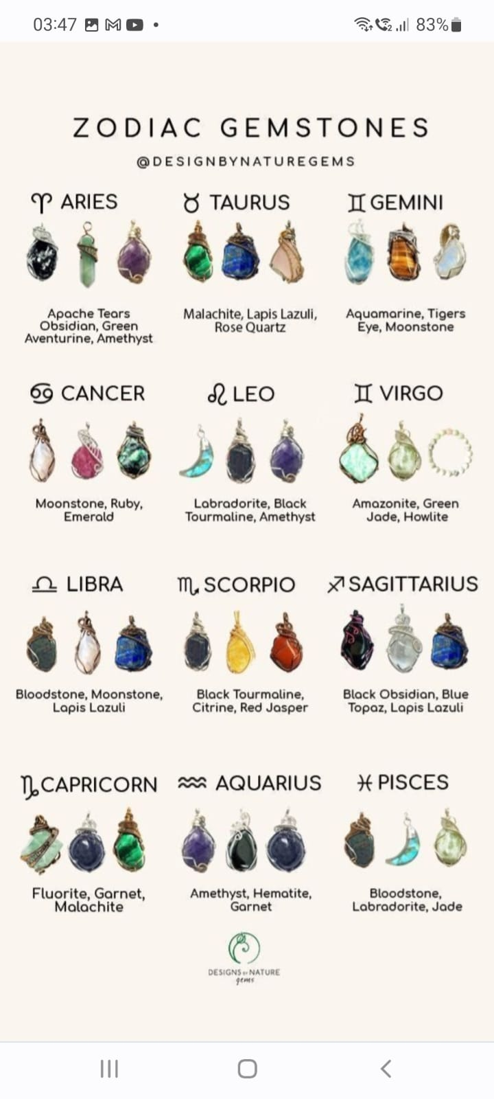

**3. SIGN LANGUAGE**

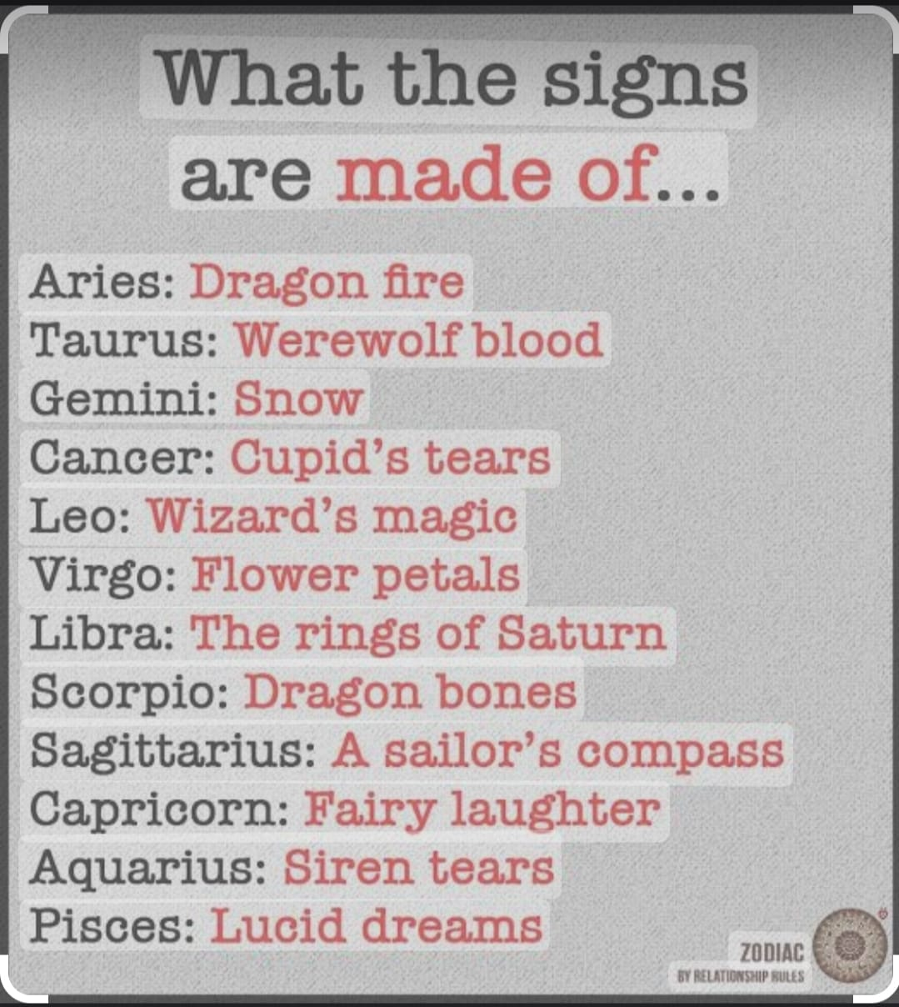

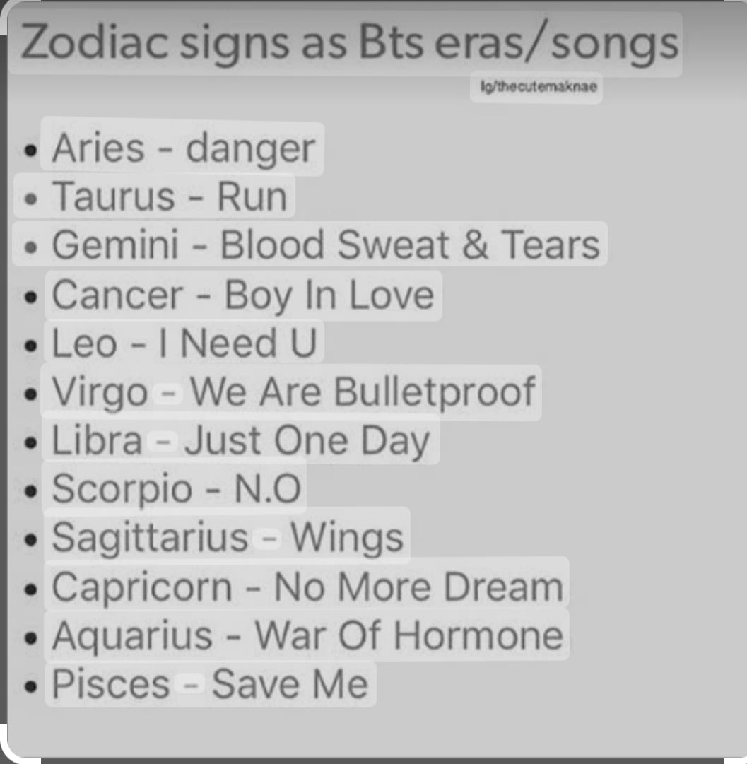

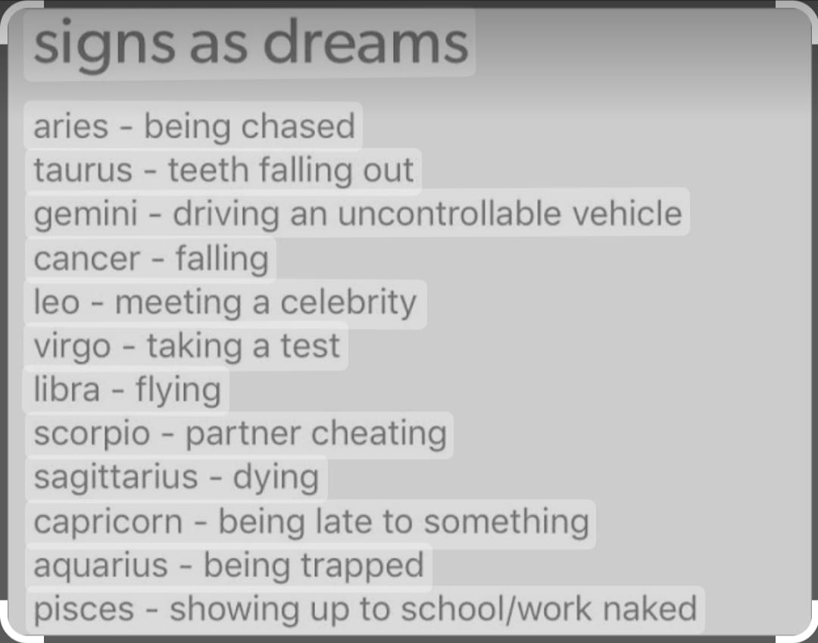

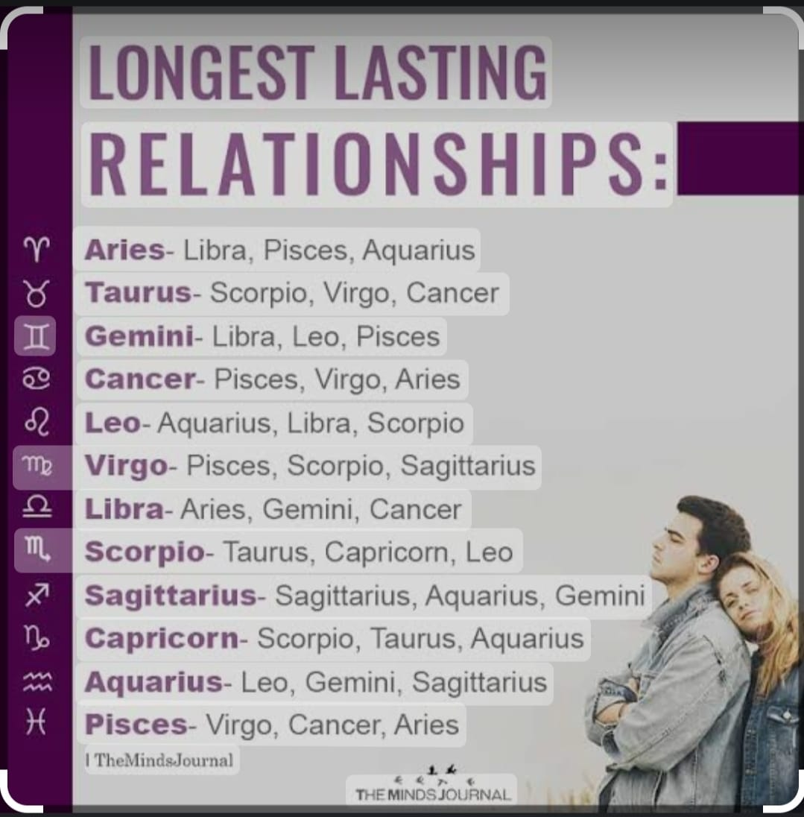

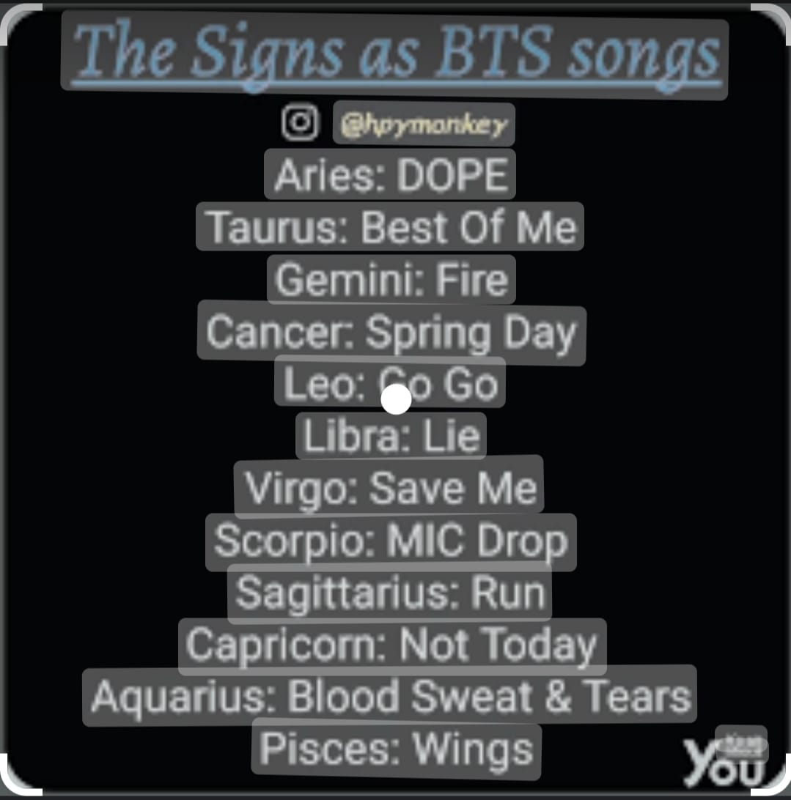

**4. STARS**

|  |  |  |  |
| --- | --- | --- | --- |
|  | **Nakshatra Name** |  | **NakshatraLord** |
| **Ashwini** | **Magha** | **Mula** | **Ketu (south node)** |
| **Bharani** | **Phalguni(pubba)/Purva** | **Purva Ashadha** | **Venus** |
| **Krittika** | **Uttara Phalguni(Uttara)** | **Uttara Ashadha** | **Sun** |
| **Rohini** | **Hasta** | **Shravana** | **Moon** |
| **Mrigashirsha** | **Chitra** | **Dhanishtha** | **Mars** |
| **Ardra** | **Swati** | **Shatabhishak** | **Rahu (north node)** |
| **Punarvasu** | **Vishakha** | **Purva Bhadra** | **Jupiter** |
| **Pushya** | **Anuradha** | **Uttara Bhadra** | **Saturn** |
| **Aslesha** | **Jyestha** | **Revati** | **Mercury** |

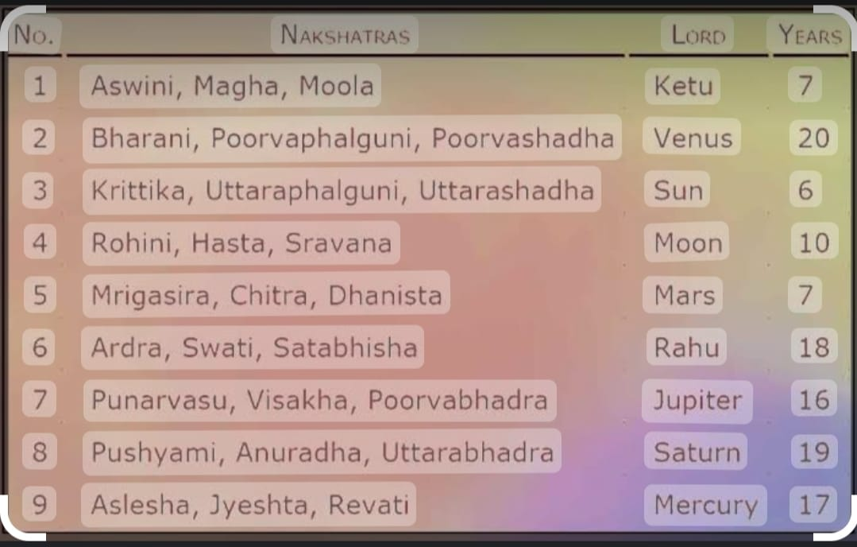

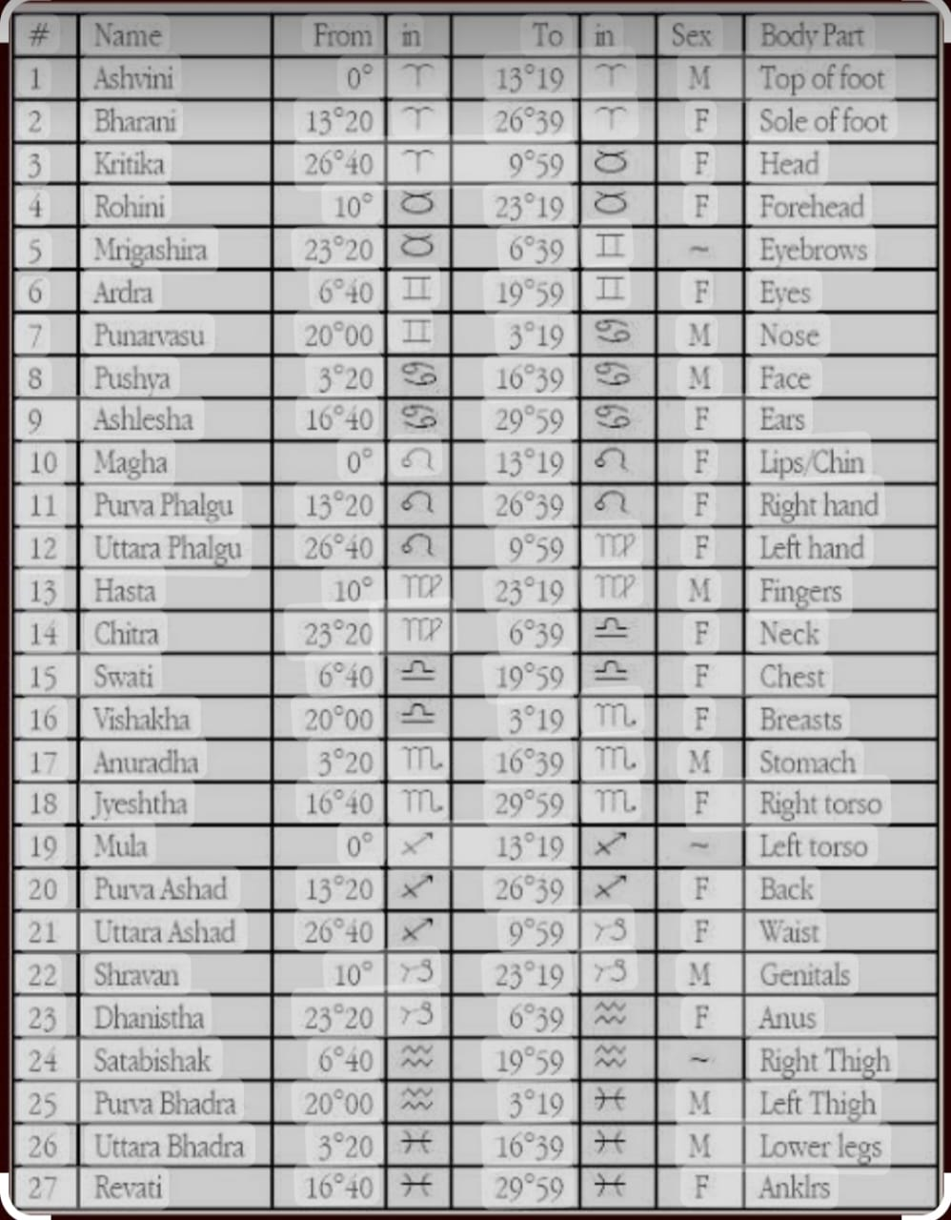

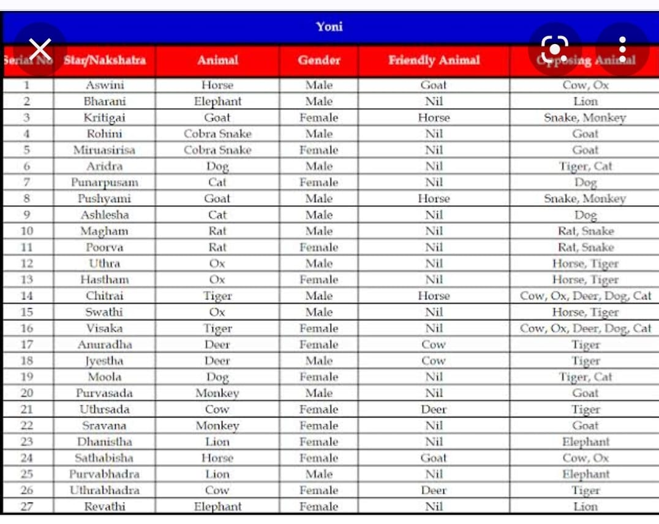

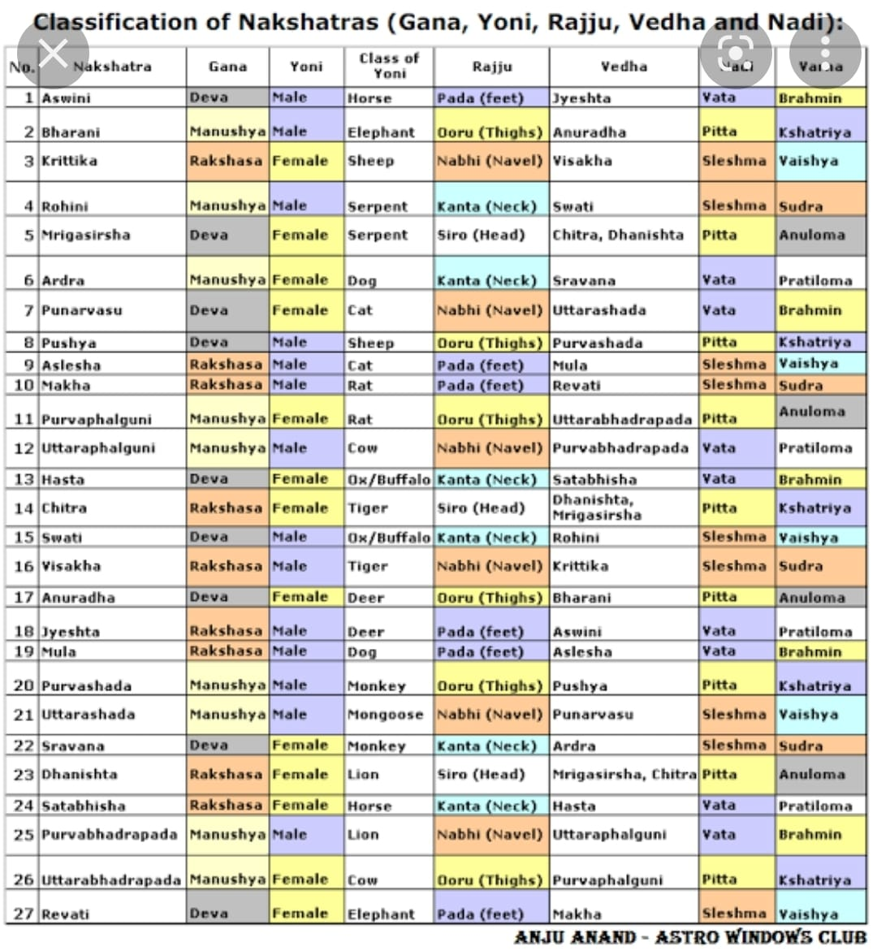

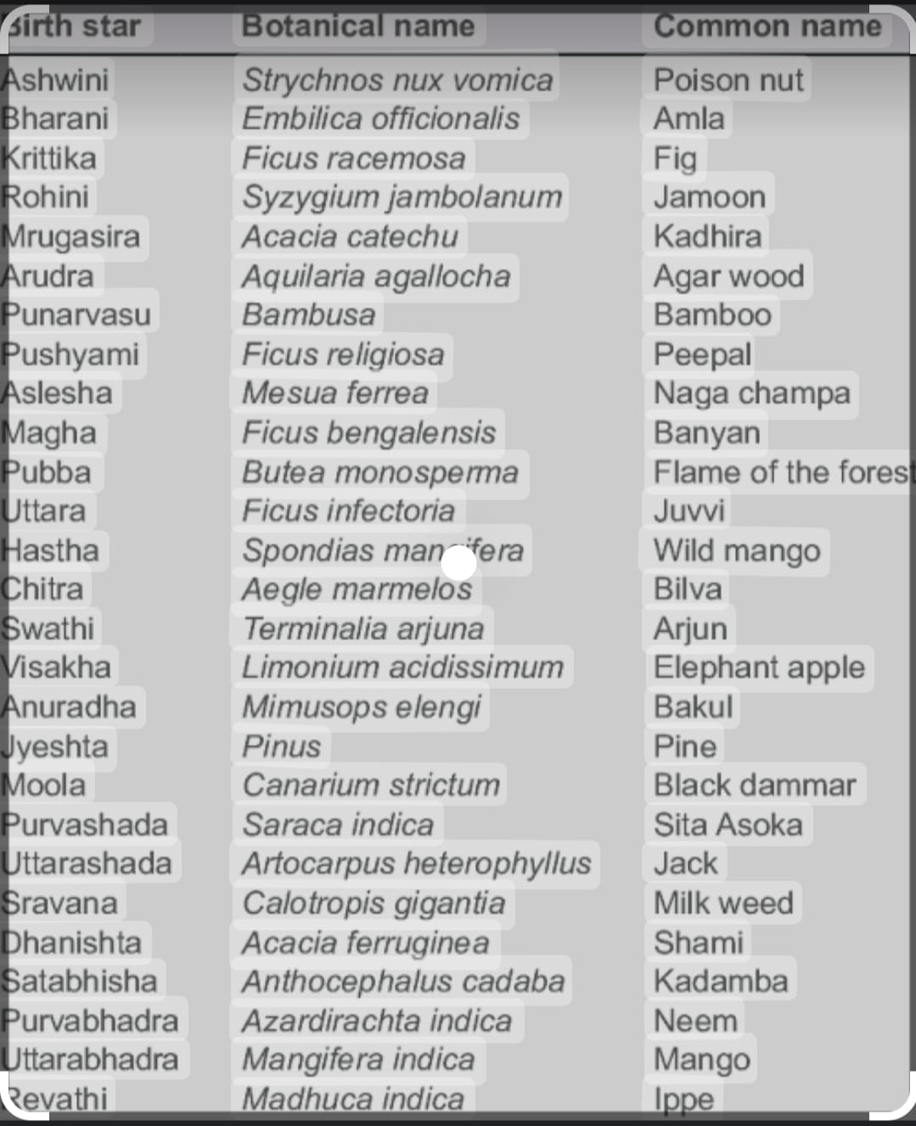

|  |  |  |  |  |  |  |  |  |  |  |  |
| --- | --- | --- | --- | --- | --- | --- | --- | --- | --- | --- | --- |
|  |  |  |  |  |  |  |  |  |  |  |  |
| **Nakshatra** | **Lord** | **Yoni** | **Guna** | **Presiding Diety** | **Opposition** | **SuklaPaksha** | **KrishnaPaksha** | **Morning[3.30-11.30]** | **Afternoon[11.31-19.30]** | **Night[19.31-N03.29]** |
| 1. Ashwini. | Ketu | Horse | Deva | Ashwini Kumar | 22. Shravana. | Vulture | Peacock |  |  |  |
| 2. Bhairini | Venus | Elephant | Manushya | Yama | 23. Dhanista | Vulture | Peacock |  |  |  |
| 3. Krittika. | Sun | Goat | Rakshasa | Agni | 24. Satabisa | Vulture | Peacock |  |  |  |
| 4. Rohini. | Moon | Serpent | Manushya | Brahma | 25. P.Bhadra. | Vulture | Peacock |  |  |  |
| 5. Mrigasira. | Mars | Serpent | Deva | Soma | 26. U.Bhadra. | Vulture | Peacock |  |  |  |
| 6. Ardra | Rahu | Dog | Manushya | Rudra | 27. Revati | Owl | Cock |  |  |  |
| 7. P.Vasu. | Jupiter | Cat | Deva | Aditi | 1. Ashwini. | Owl | Cock |  |  |  |
| 8. Pushya | Saturn | Goat | Deva | Brihaspati | 2. Bhairini | Owl | Cock |  |  |  |
| 9. Aslesha | Mercury | Cat | Rakshasa | Ahi | 3. Krittika. | Owl | Cock |  |  |  |
| 10. Magha | Ketu | Rat | Rakshasa | Pitragana | 4. Rohini. | Owl | Cock |  |  |  |
| 11. P.Phalguni. | Venus | Rat | Manushya | Bhagya | 5. Mrigasira. | Owl | Cock |  |  |  |
| 12. U. halguni. | Sun | Cow | Manushya | Surya | 6. Ardra | Crow | Crow |  |  |  |
| 13. Hasta. | Moon | Buff | Deva | Savita | 7. P.Vasu. | Crow | Crow |  |  |  |
| 14. Chitra. | Mars | Tiger | Rakshasa | Vishwakarma | 8. Pushya | Crow | Crow |  |  |  |
| 15. Swati. | Rahu | Buffalo | Deva | Pawan | 9. Aslesha | Crow | Crow |  |  |  |
| 16. Visakha | Jupiter | Tiger | Rakshasa | Satragni | 10. Magha | Cock | Owl |  |  |  |
| 17. Anuradha. | Saturn | Deer | Deva | Mitra | 11. P.Phalguni. | Cock | Owl |  |  |  |
| 18. Jyestha | Mercury | Deer | Rakshasa | Indra | 12. U. halguni. | Cock | Owl |  |  |  |
| 19. Moola. | Ketu | Dog | Rakshasa | Nirriti | 13. Hasta. | Cock | Owl |  |  |  |
| 20. P.asadha. | Venus | Monkey | Manushya | Toya | 14. Chitra. | Cock | Owl |  |  |  |
| 21. U.asadha. | Sun | Mongoose | Manushya | Vishwadeva | 15. Swati. | Cock | Owl |  |  |  |
| 22. Shravana. | Moon | Monkey | Deva | Hari | 16. Visakha | Peacock | Vulture |  |  |  |
| 23. Dhanista | Mars | Lion | Rakshasa | Vasu | 17. Anuradha. | Peacock | Vulture |  |  |  |
| 24. Satabisa | Rahu | Horse | Rakshasa | Varuna | 18. Jyestha | Peacock | Vulture |  |  |  |
| 25. P.Bhadra. | Jupiter | Lion | Manushya | Ajapada | 19. Moola. | Peacock | Vulture |  |  |  |
| 26. U.Bhadra. | Saturn | Cow | Manushya | Abhib adhnu | 20. P.asadha. | Peacock | Vulture |  |  |  |
| 27. Revati | Mercury | Elephant | Deva | Pushan | 21. U.asadha. | Peacock | Vulture |  |  |  |

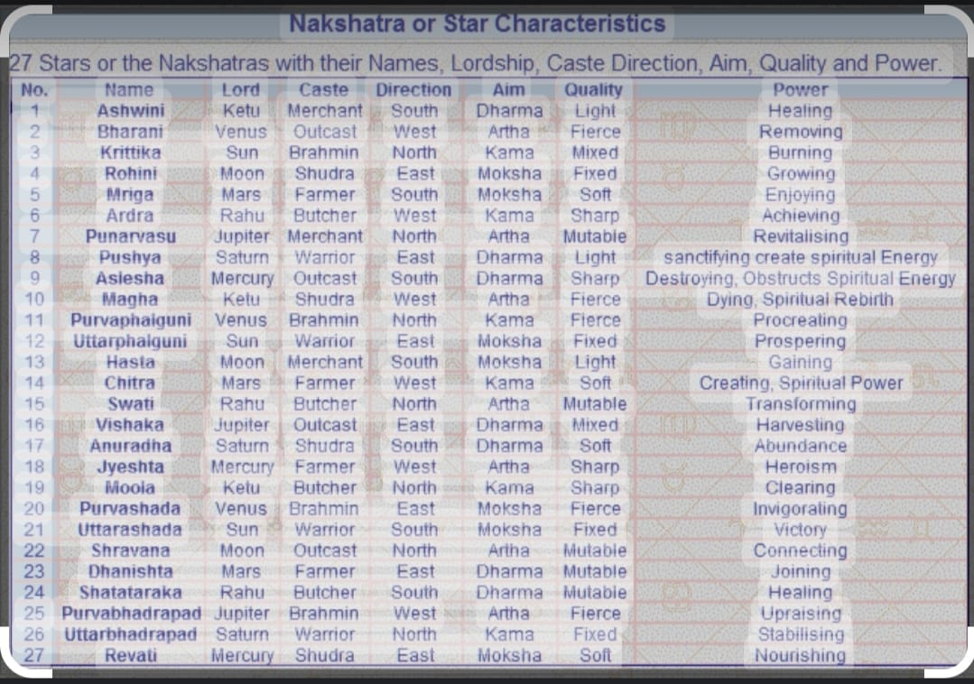

**5. STARS**

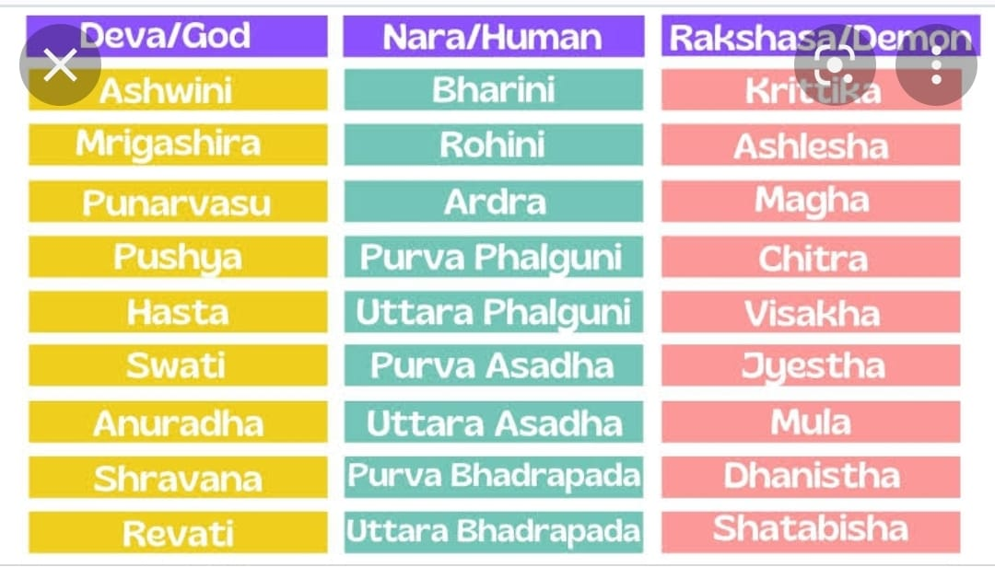

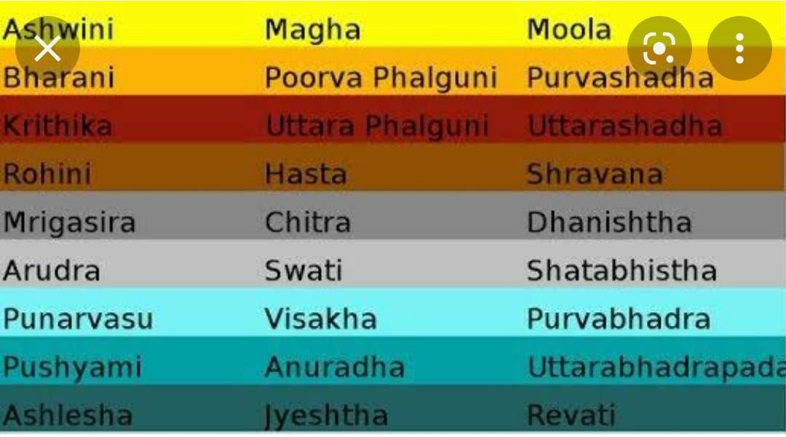

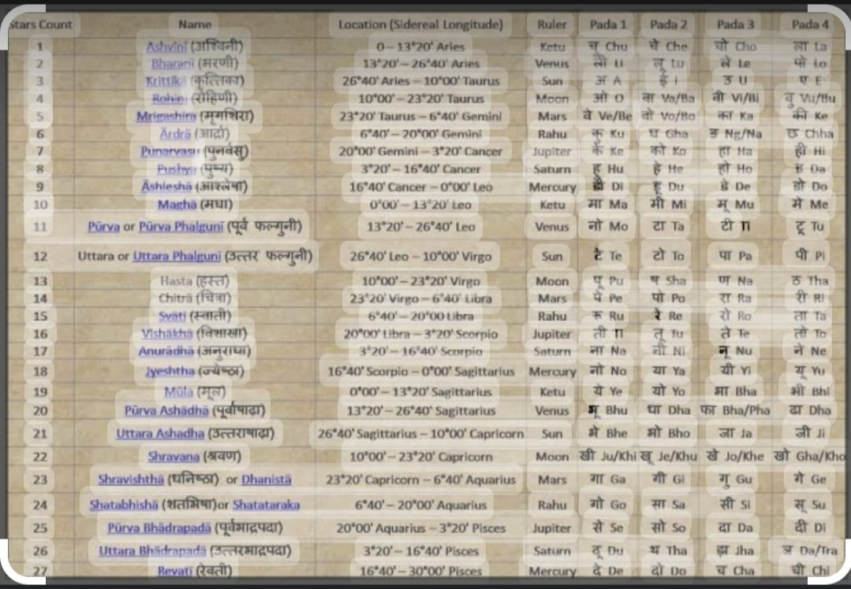

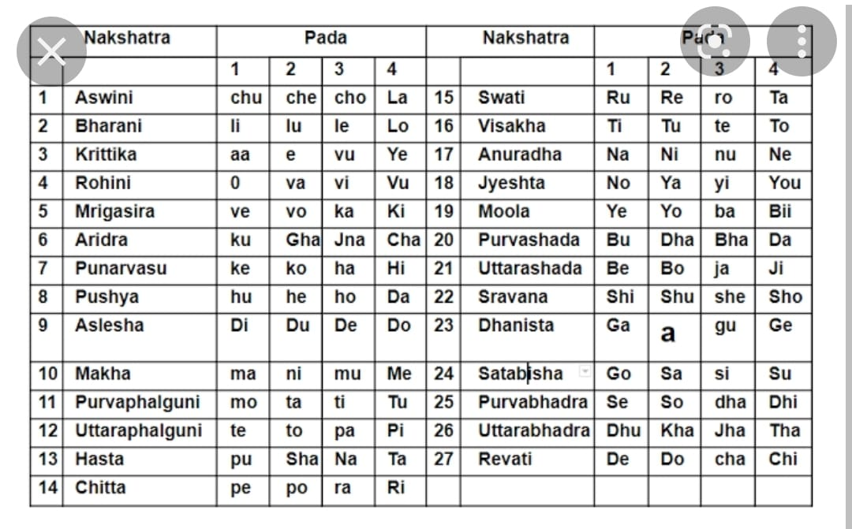

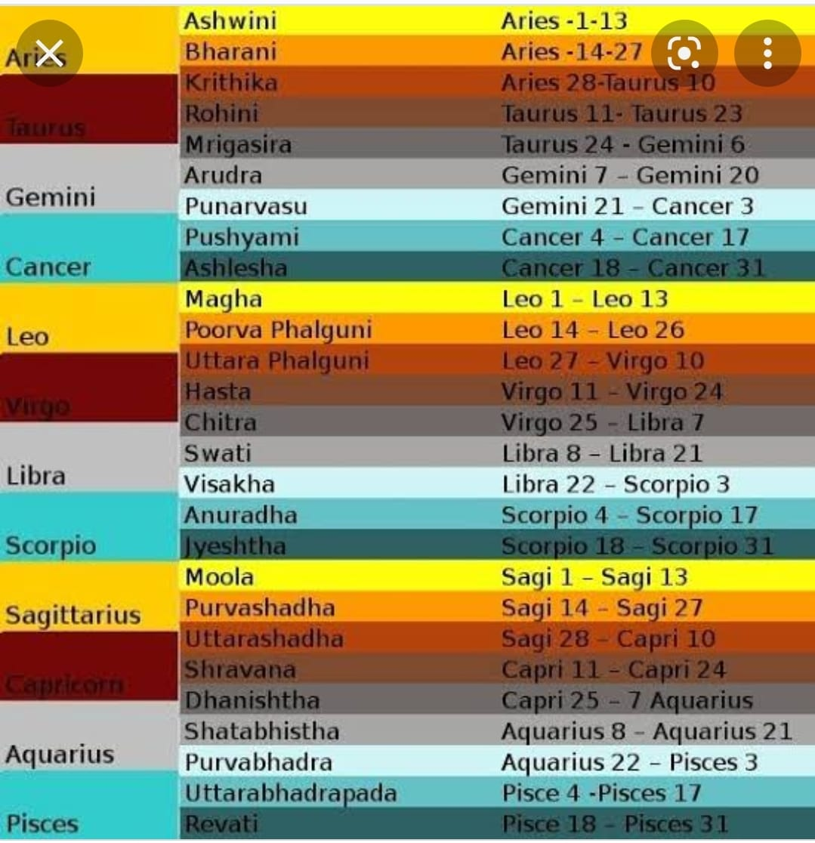

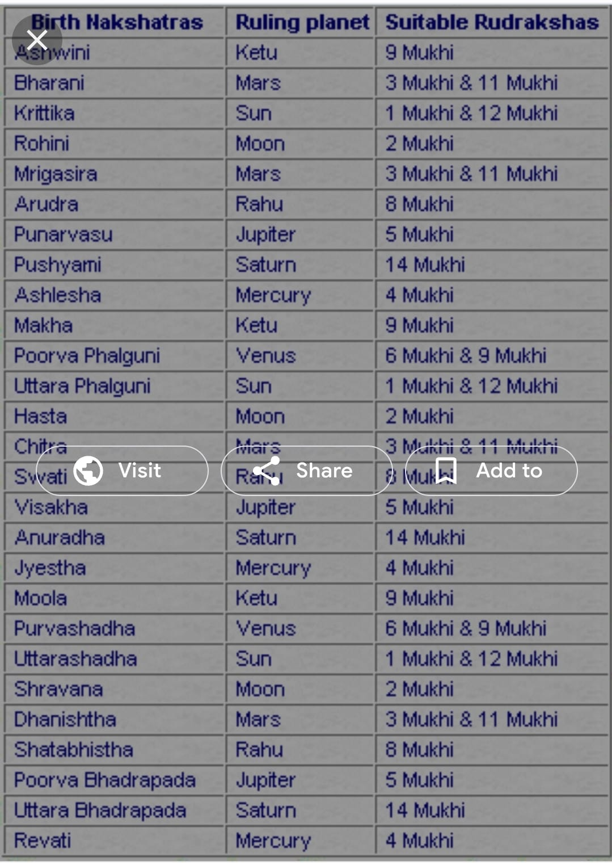

**6. CANDLES VS GEMS**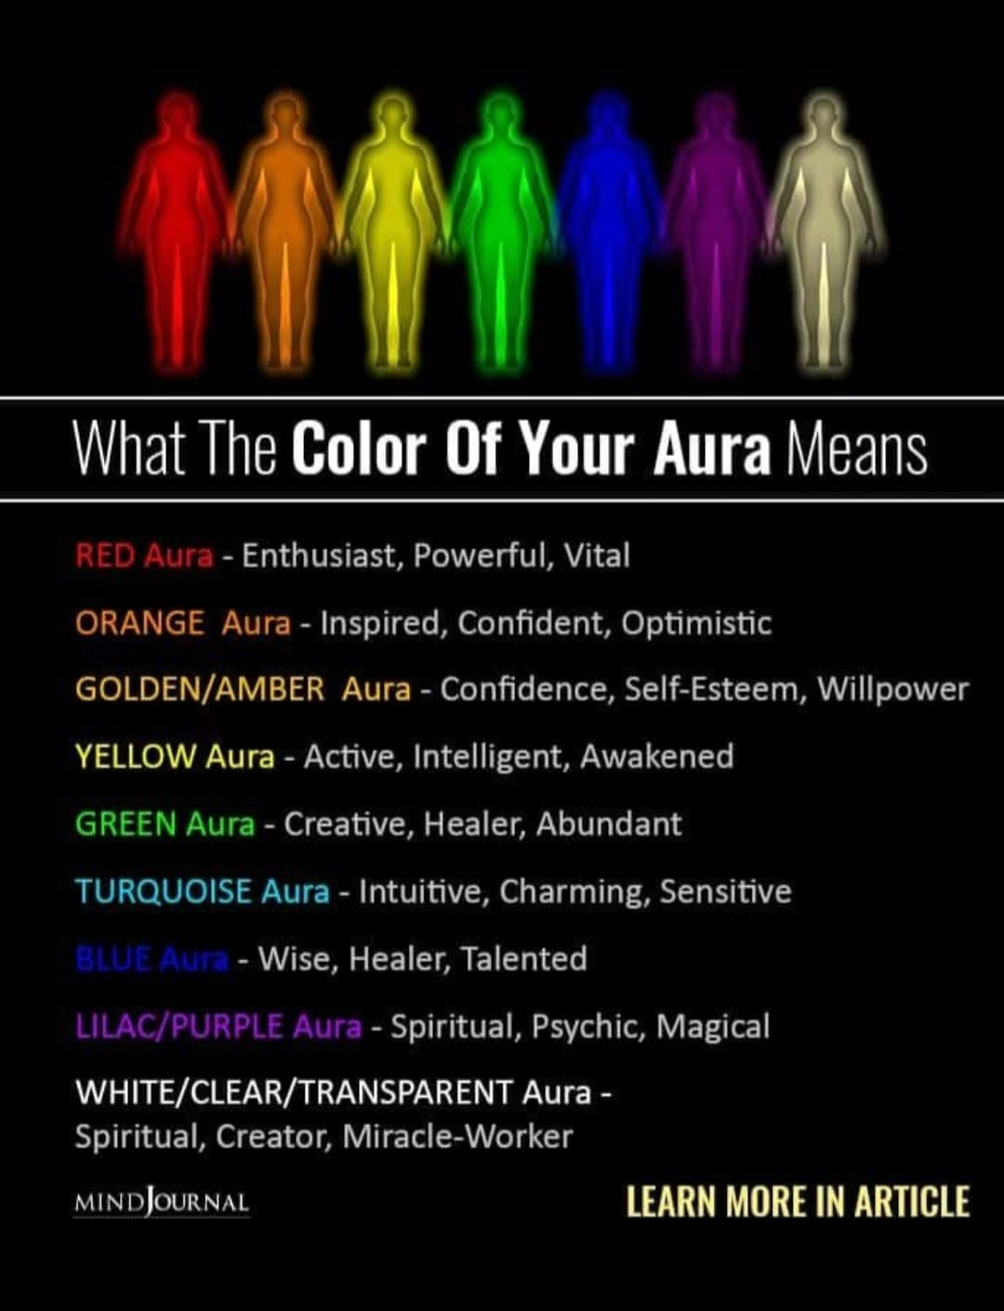

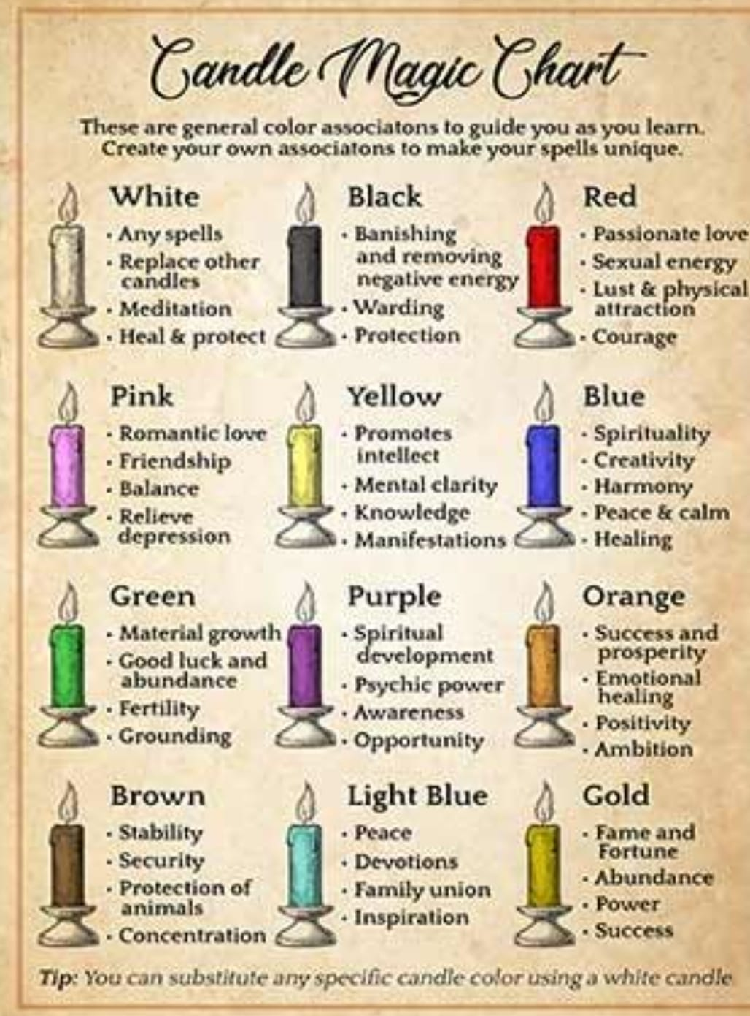

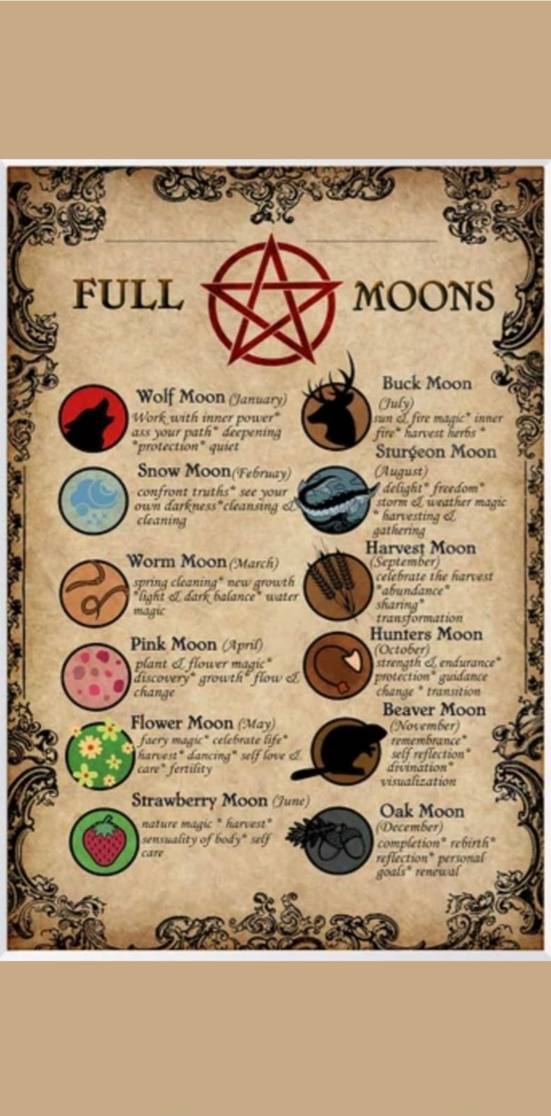



|  |  |  |  |  |
| --- | --- | --- | --- | --- |
| **C1 : O+-** | **C2 : O+-** | **C3 : B+-** | **C4 : B+-** | **C5 : A+-** |
| **C6 : A+-** | **C7 : AB+-** | **C8 : AB+-** | **C9 : B0L0** | **C10 : J1BB1L** |

**7. CHAKRAS**

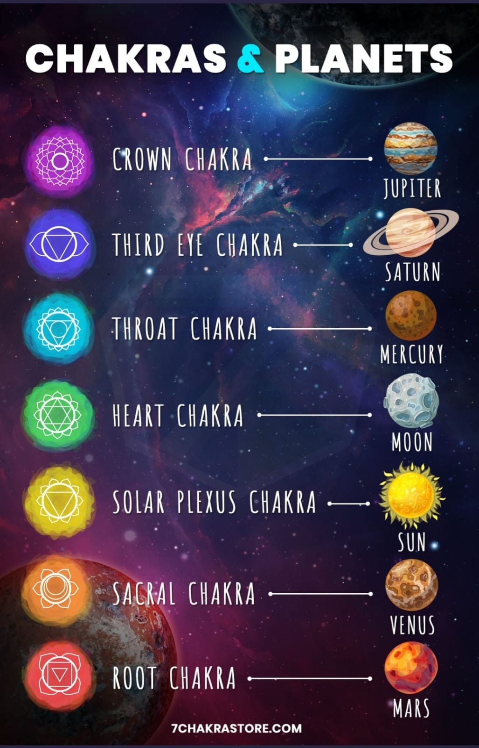

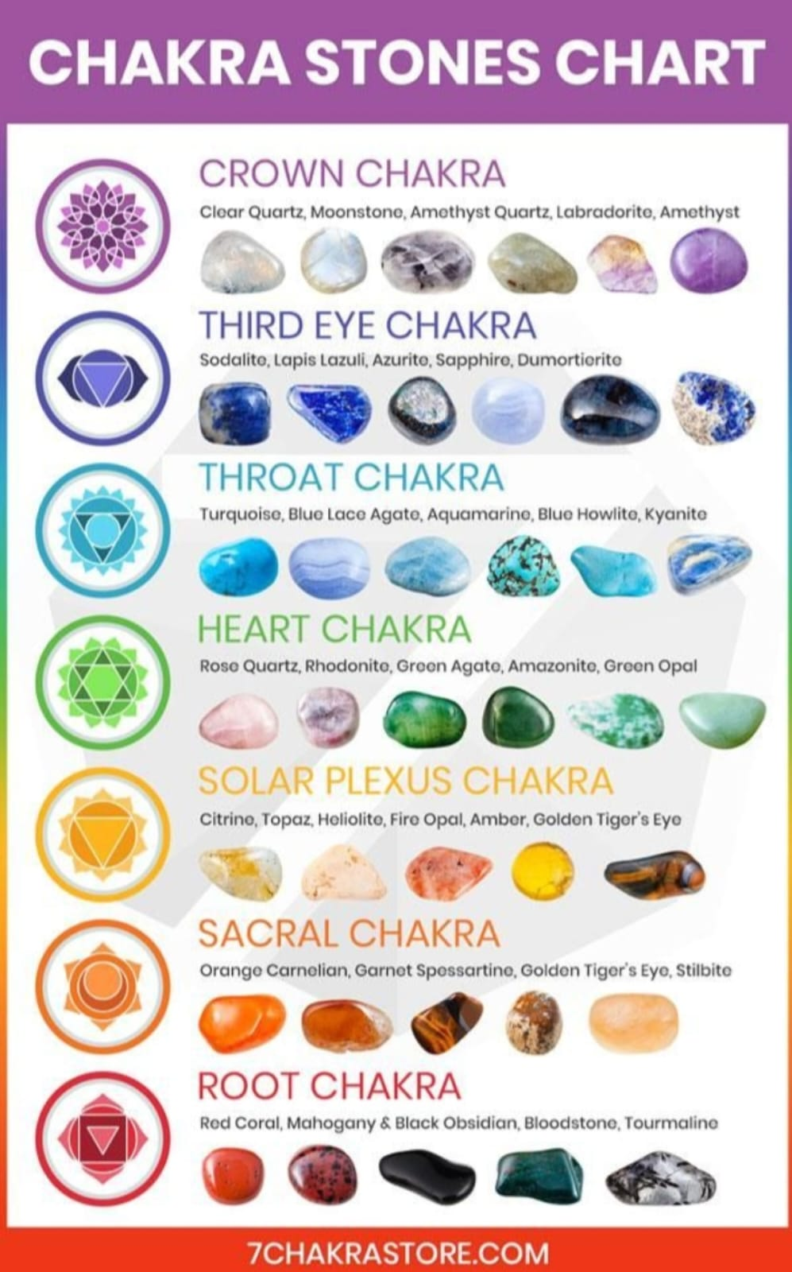

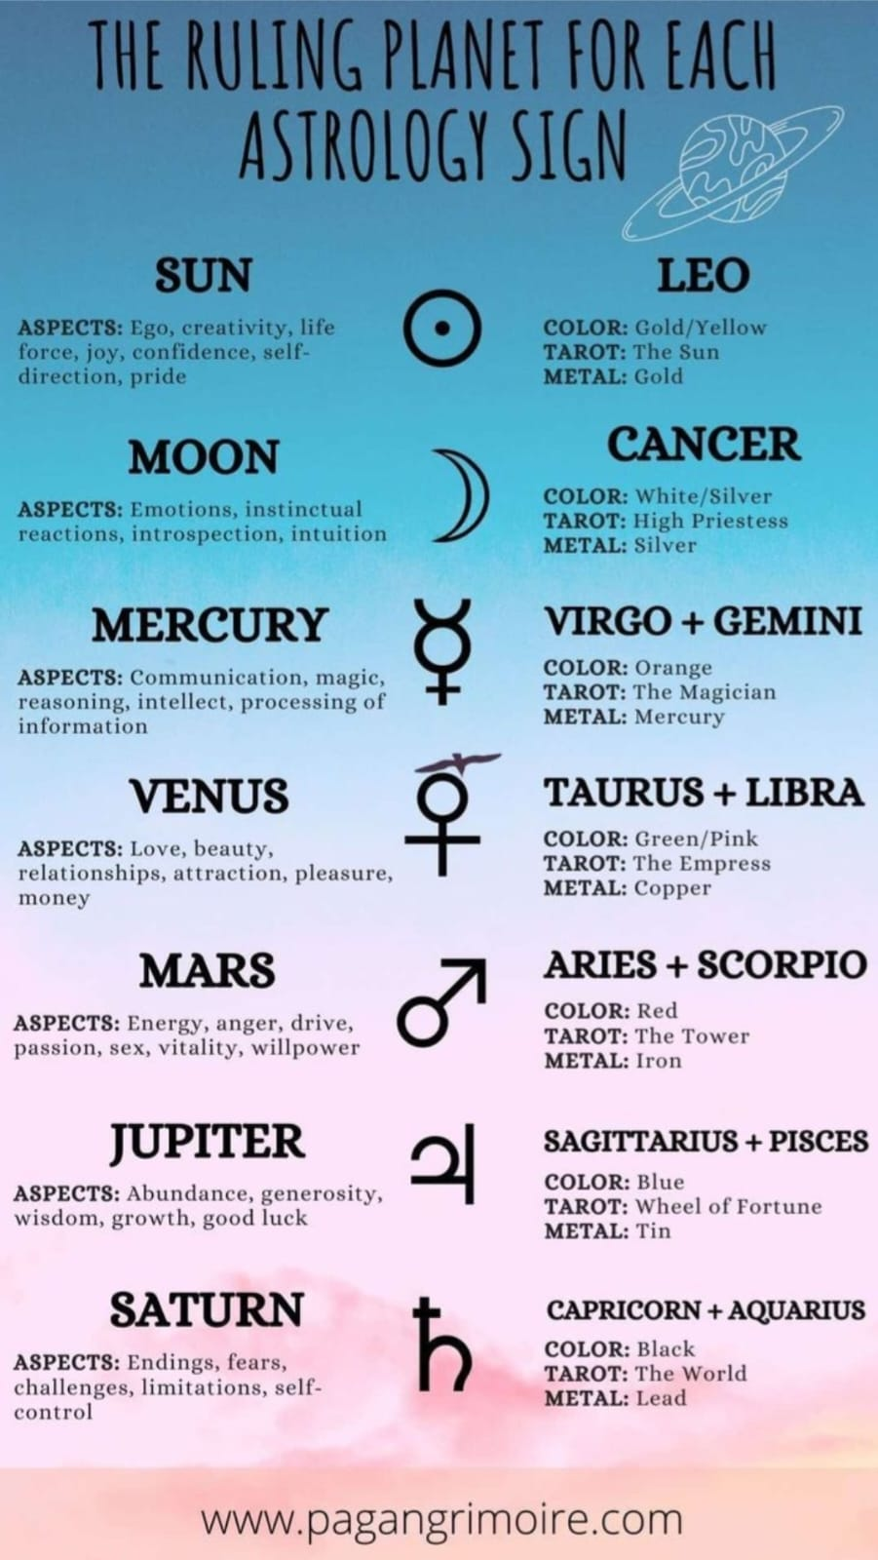

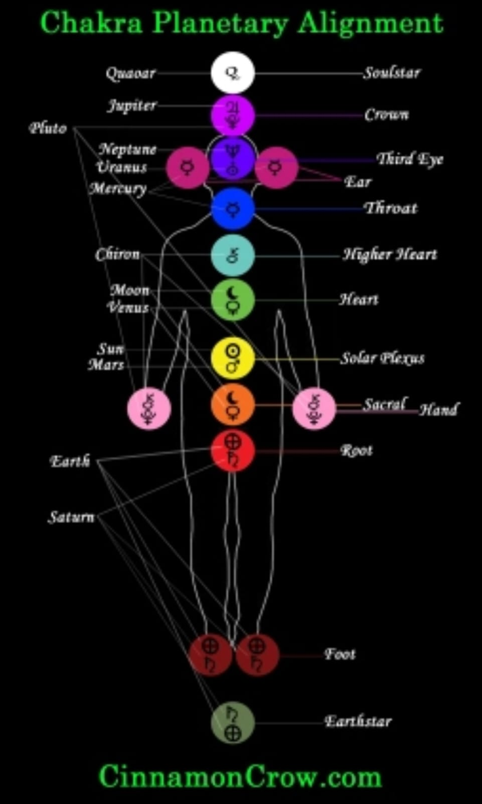

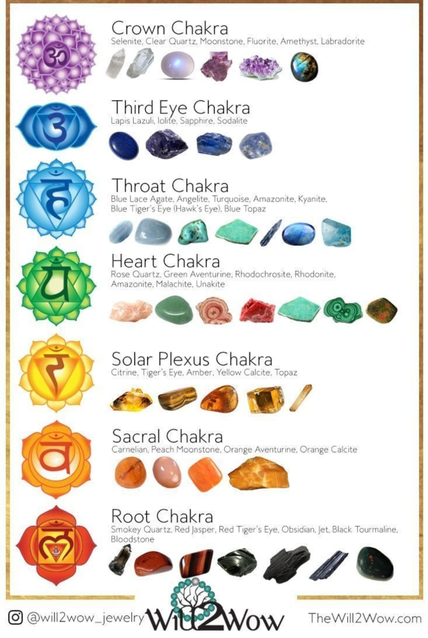

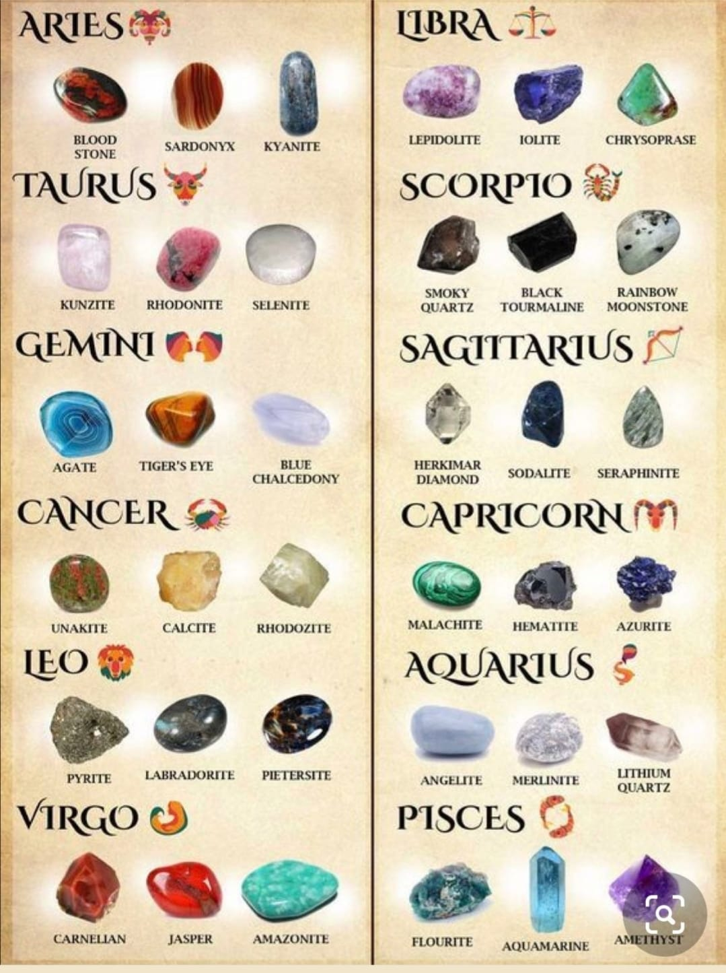

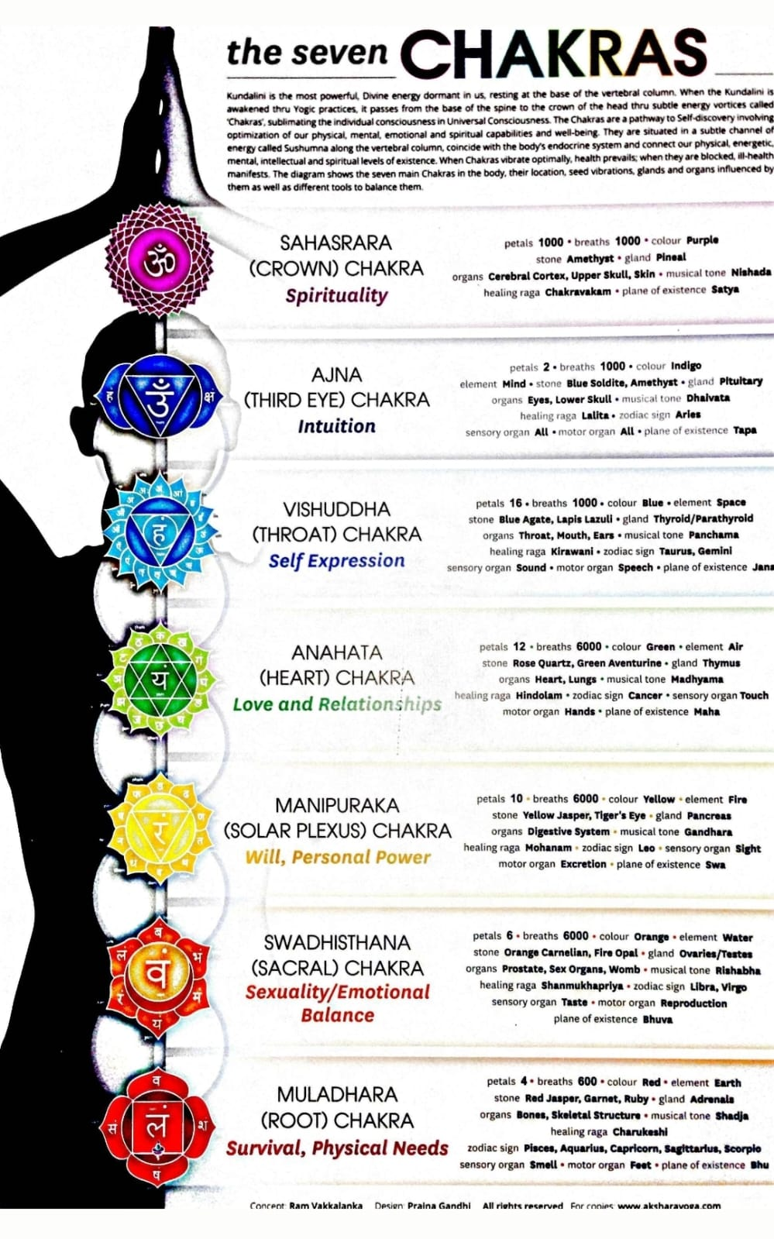

**8. PNP**

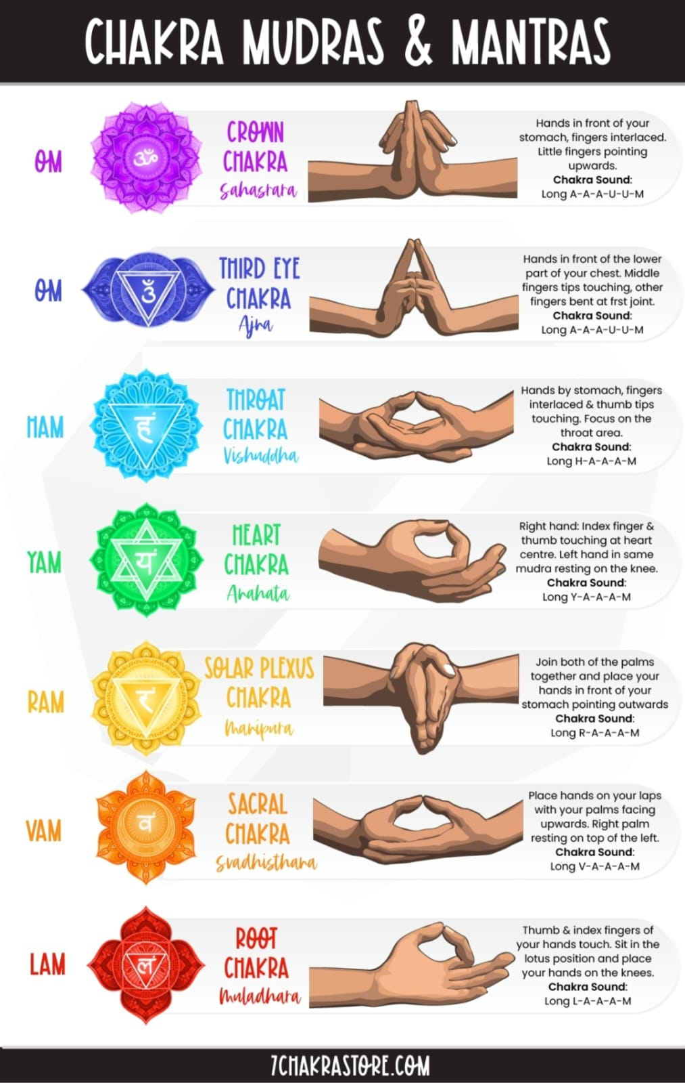

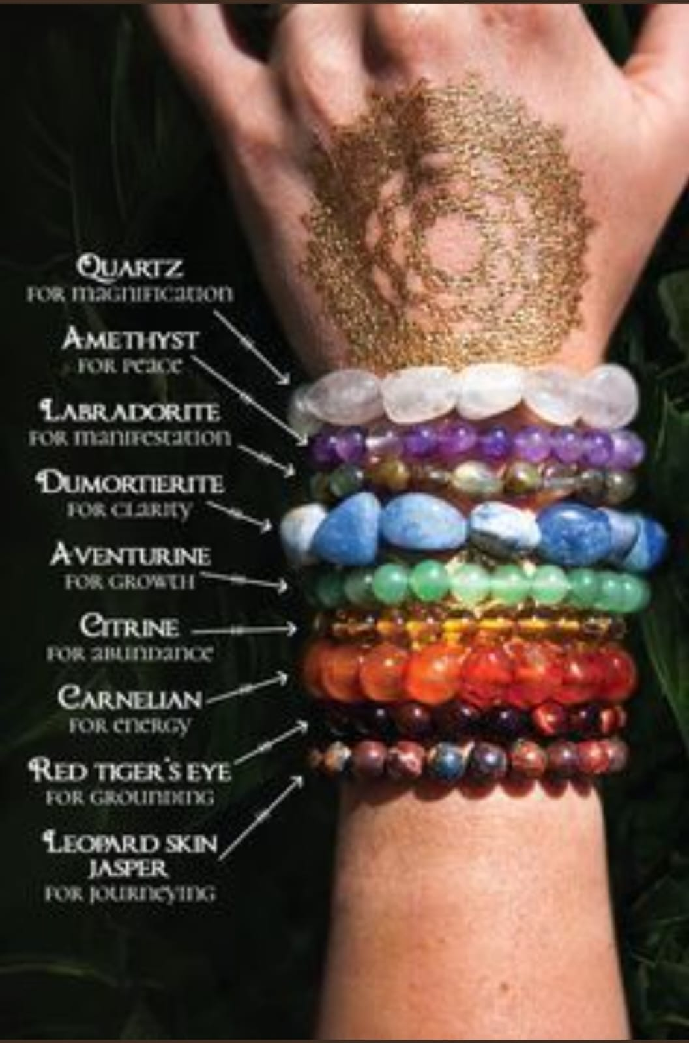

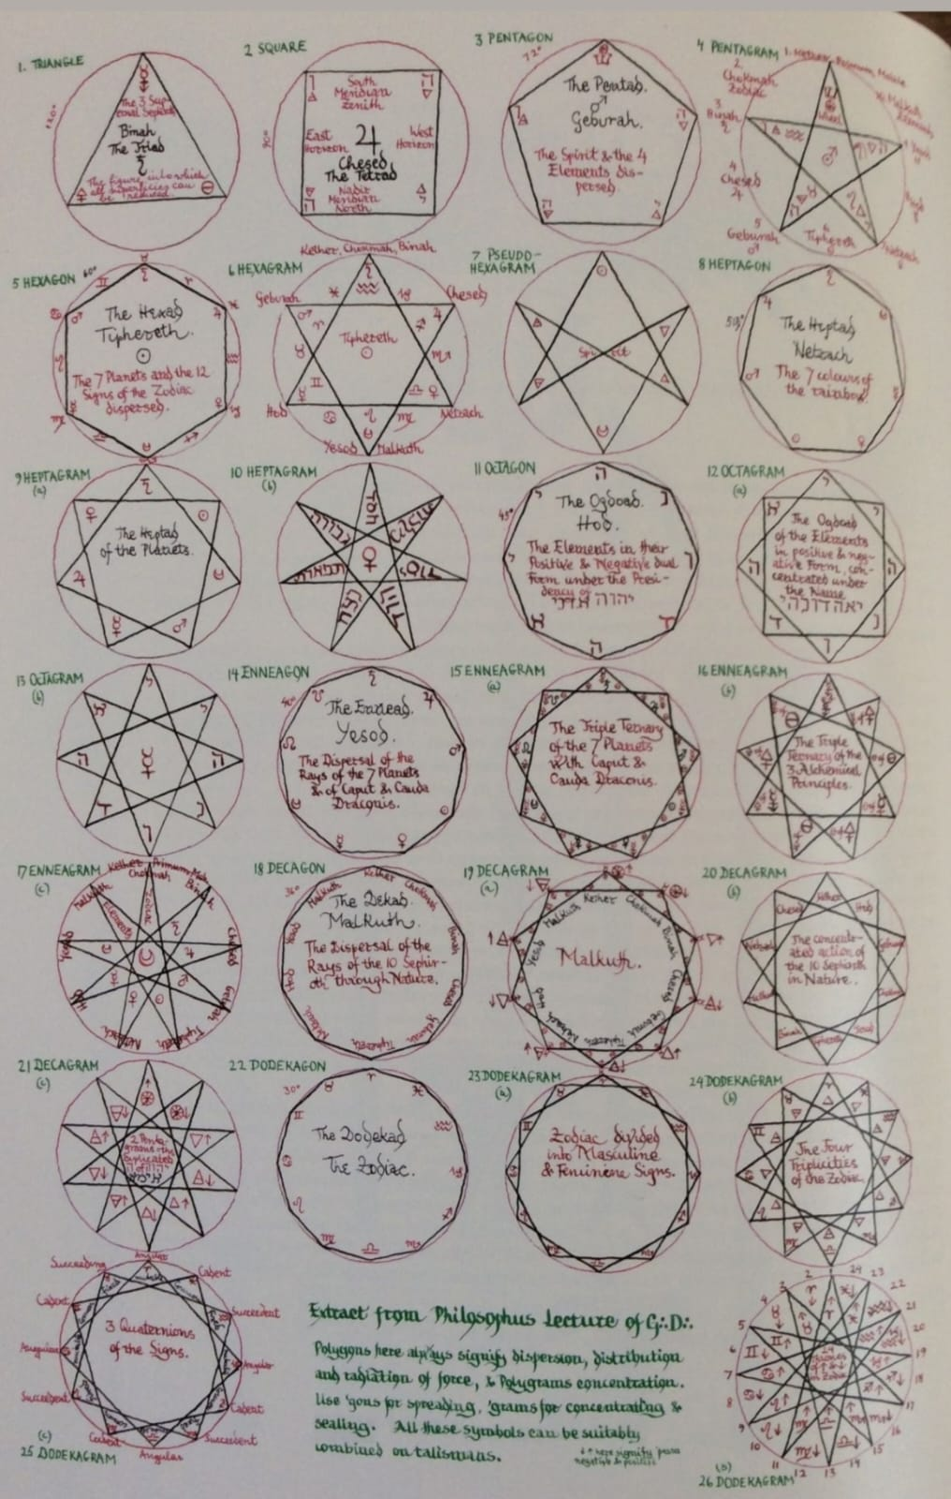

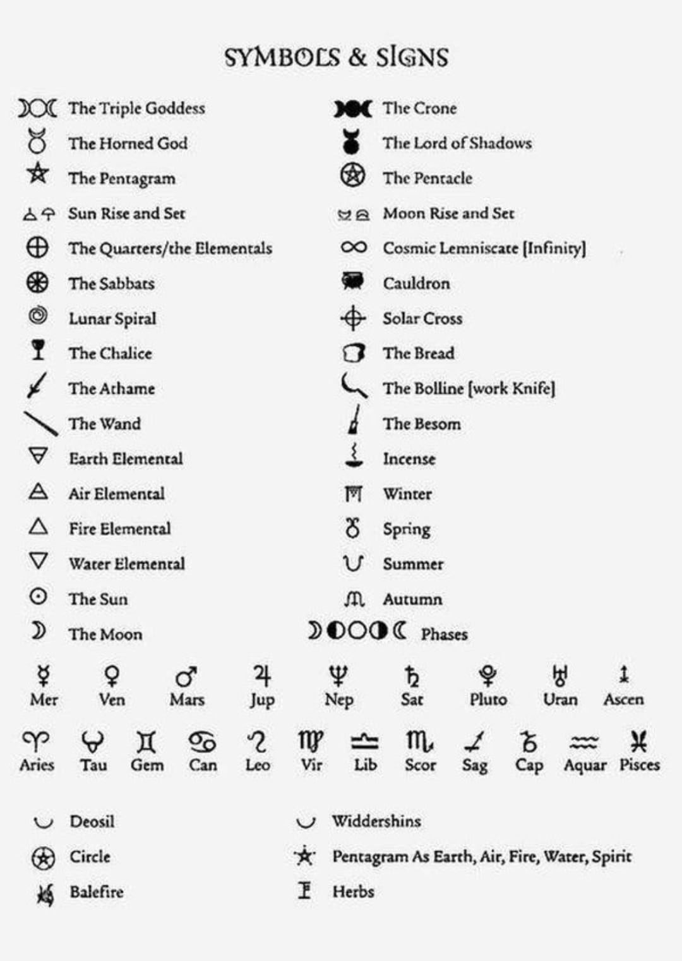



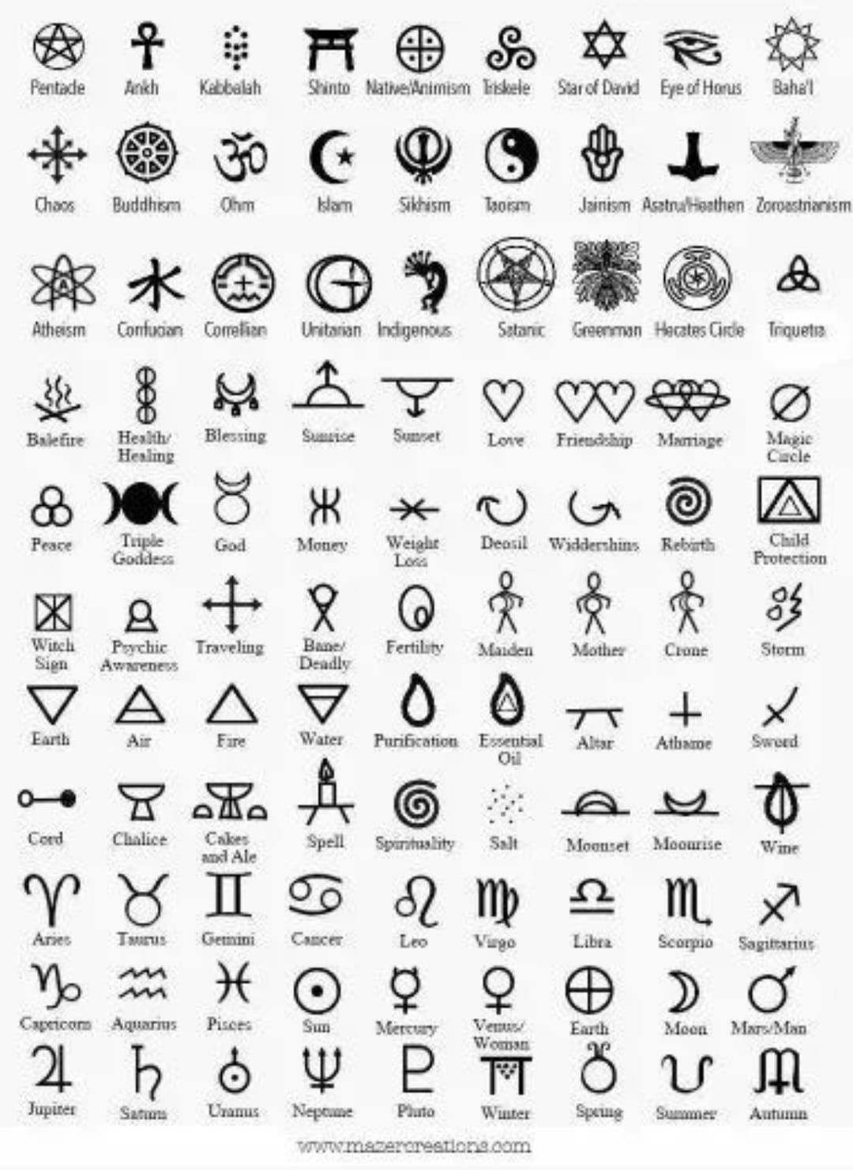

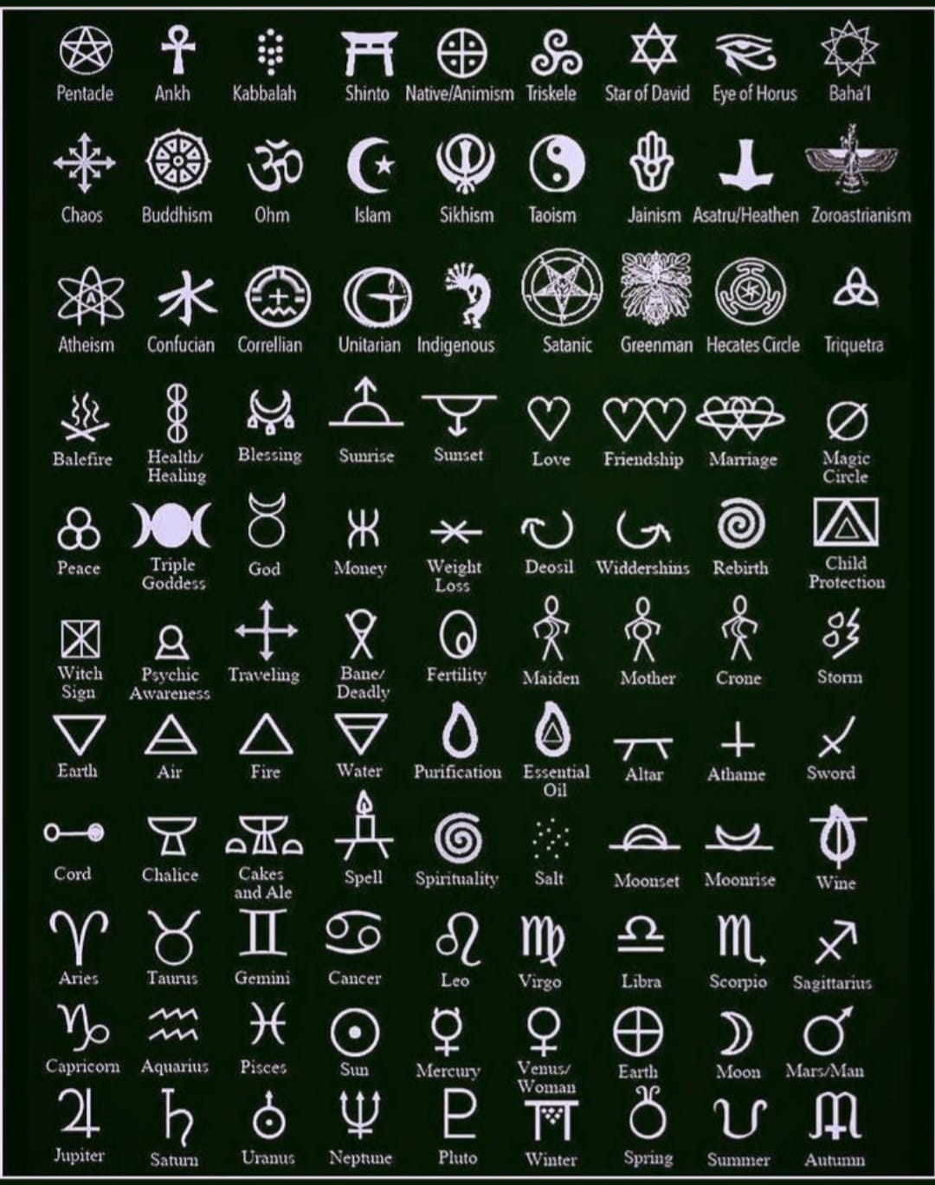

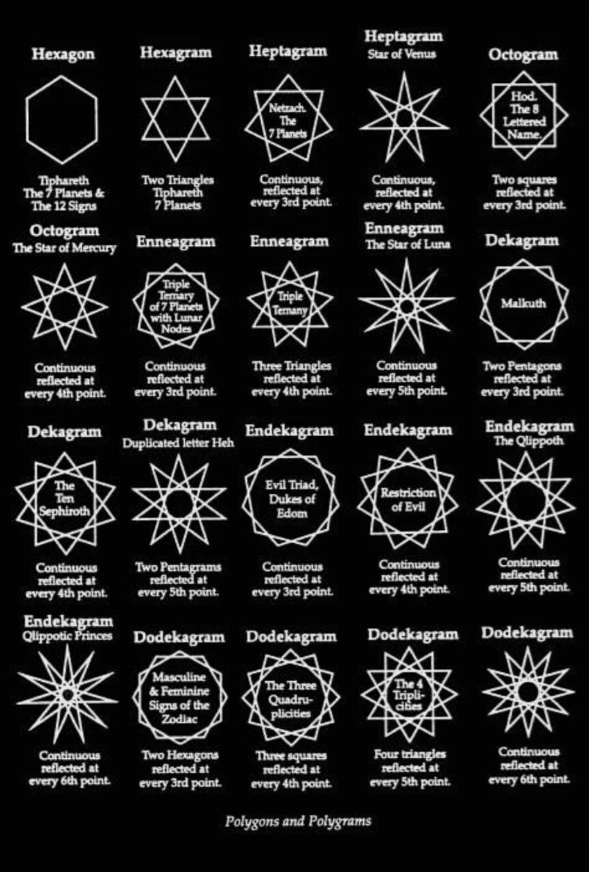

**8. BHIJ MANTRAS**

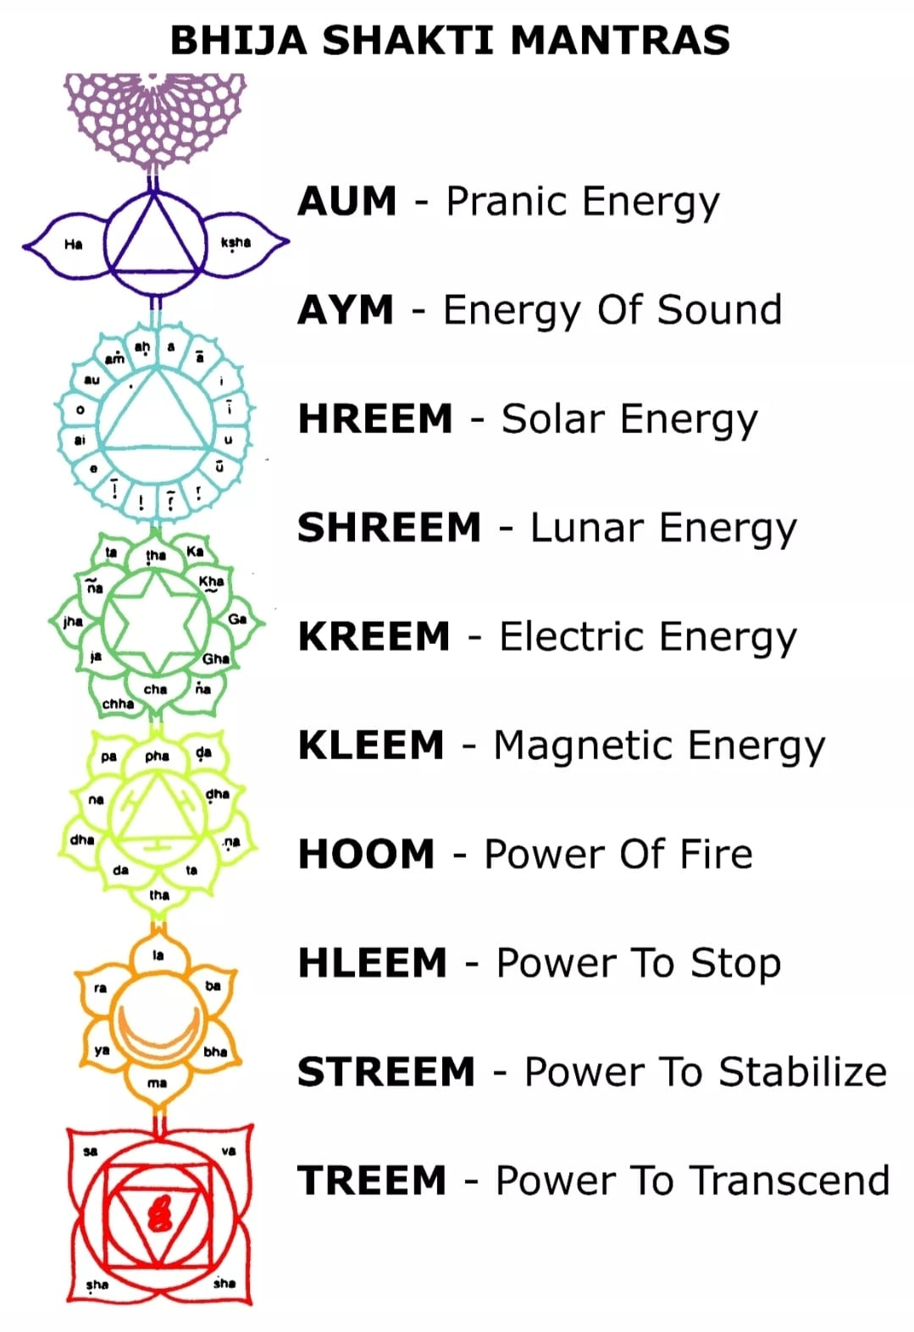

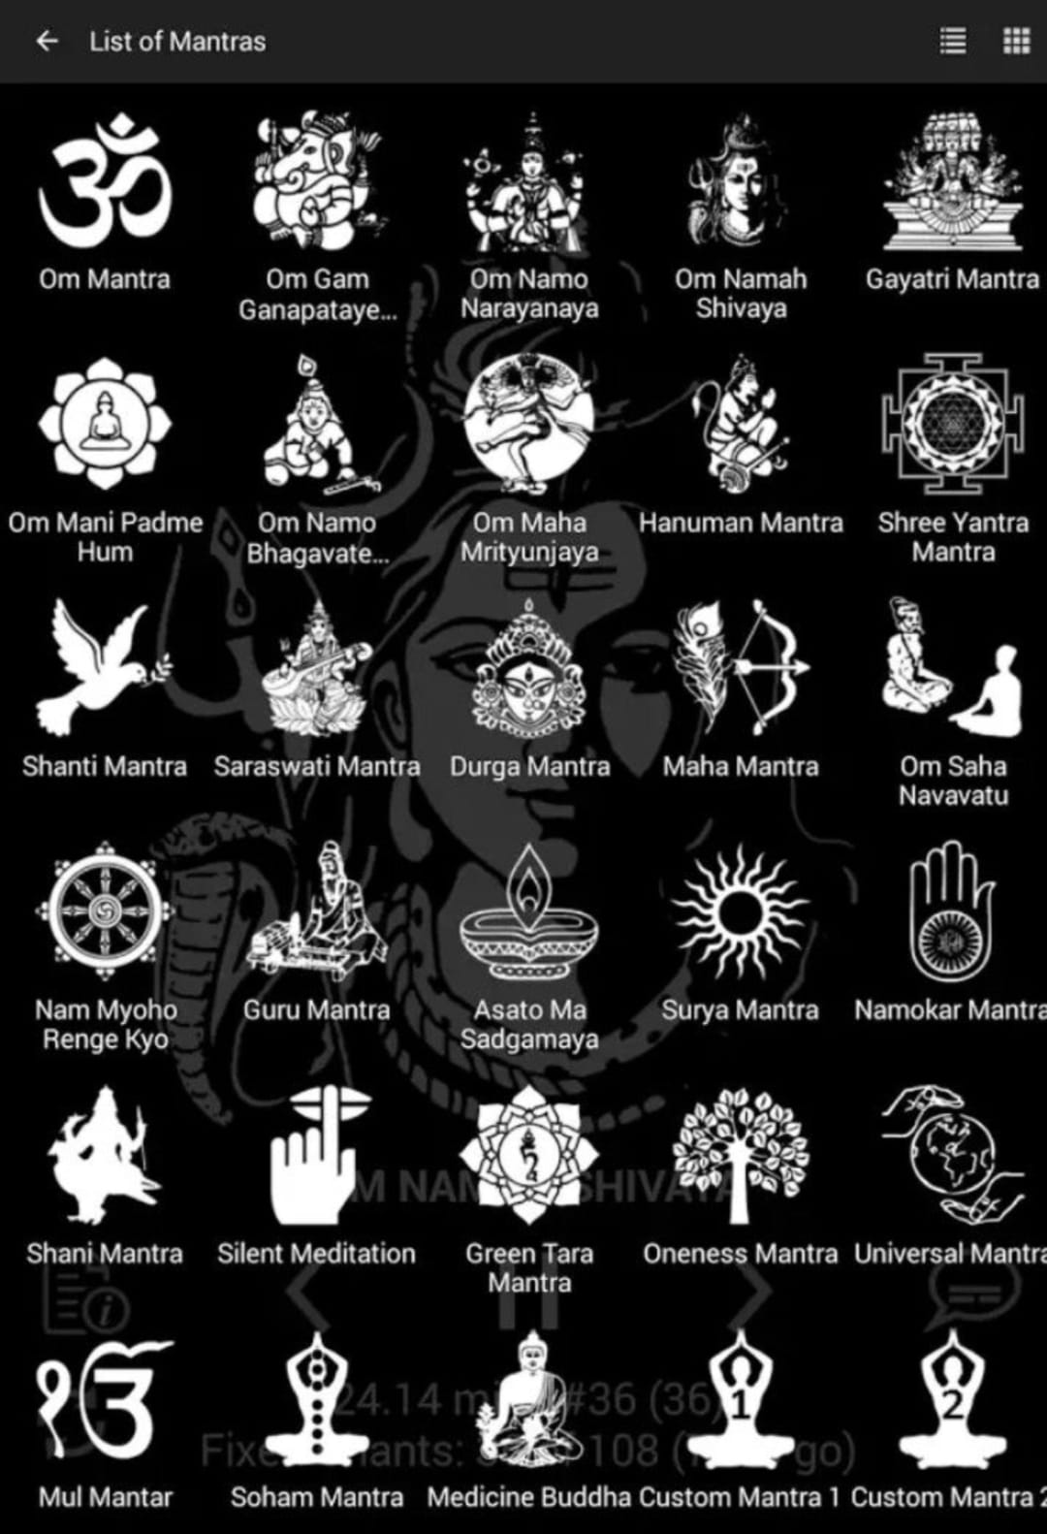

**11. ZODIAC VS STARS**

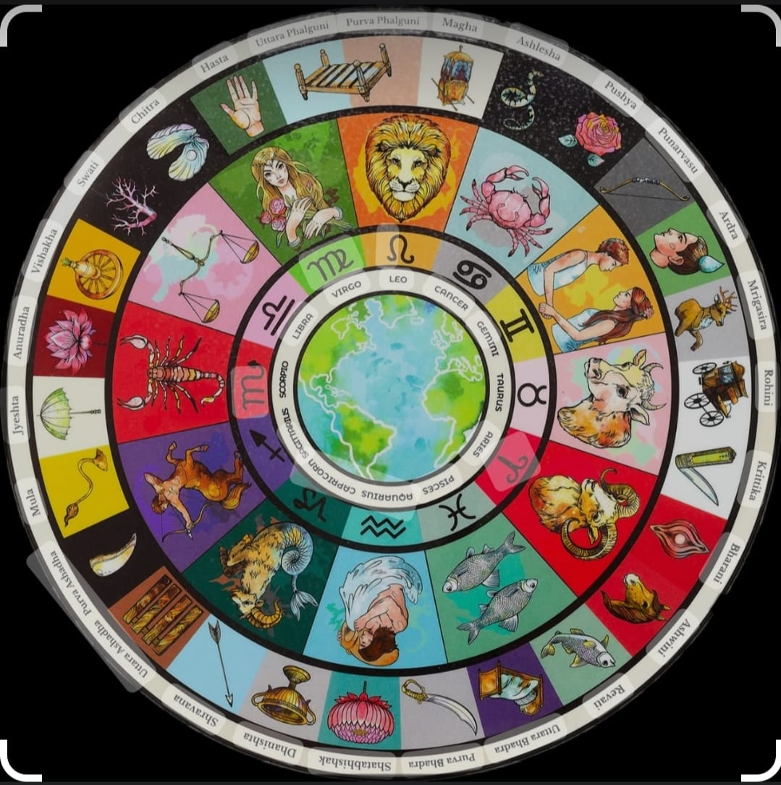

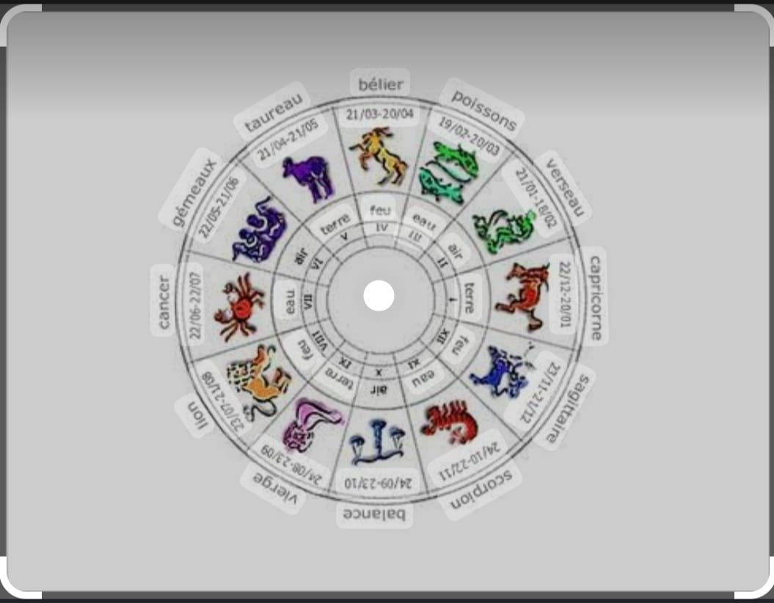

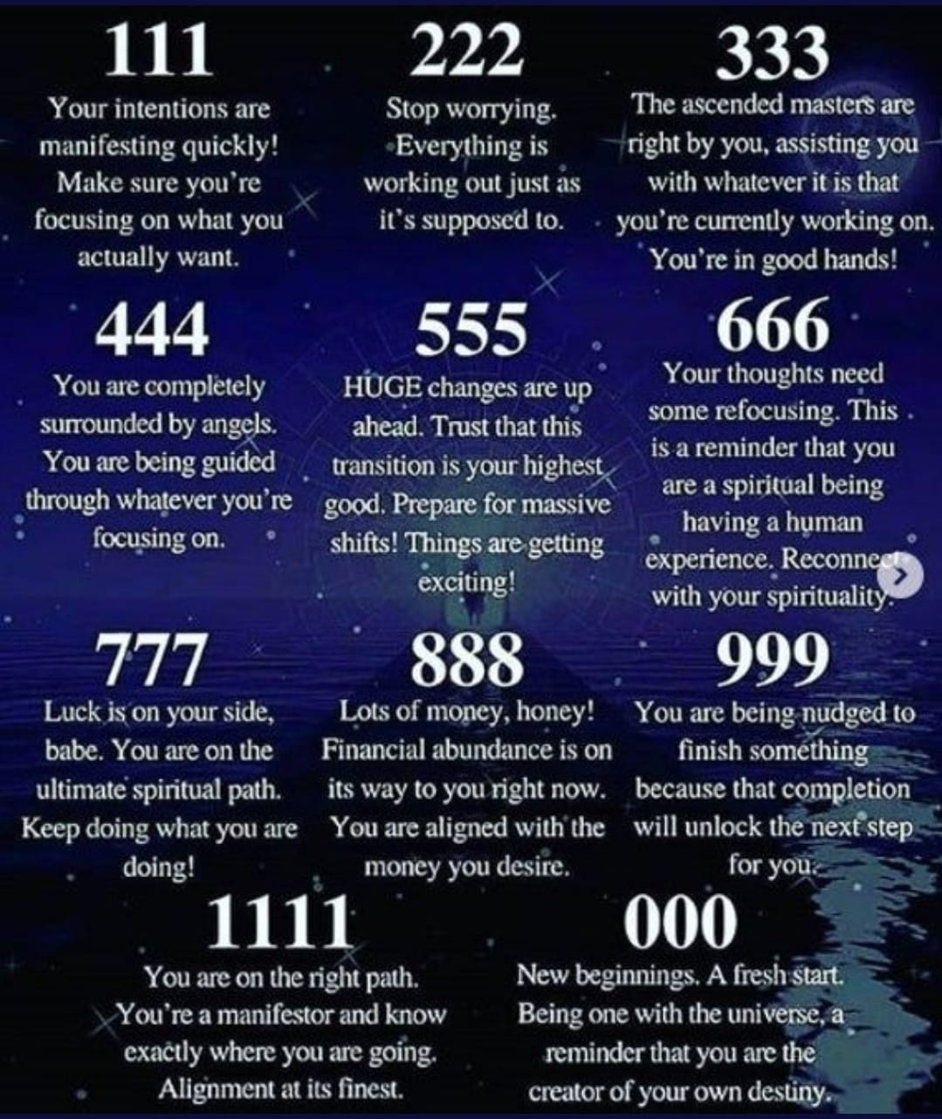

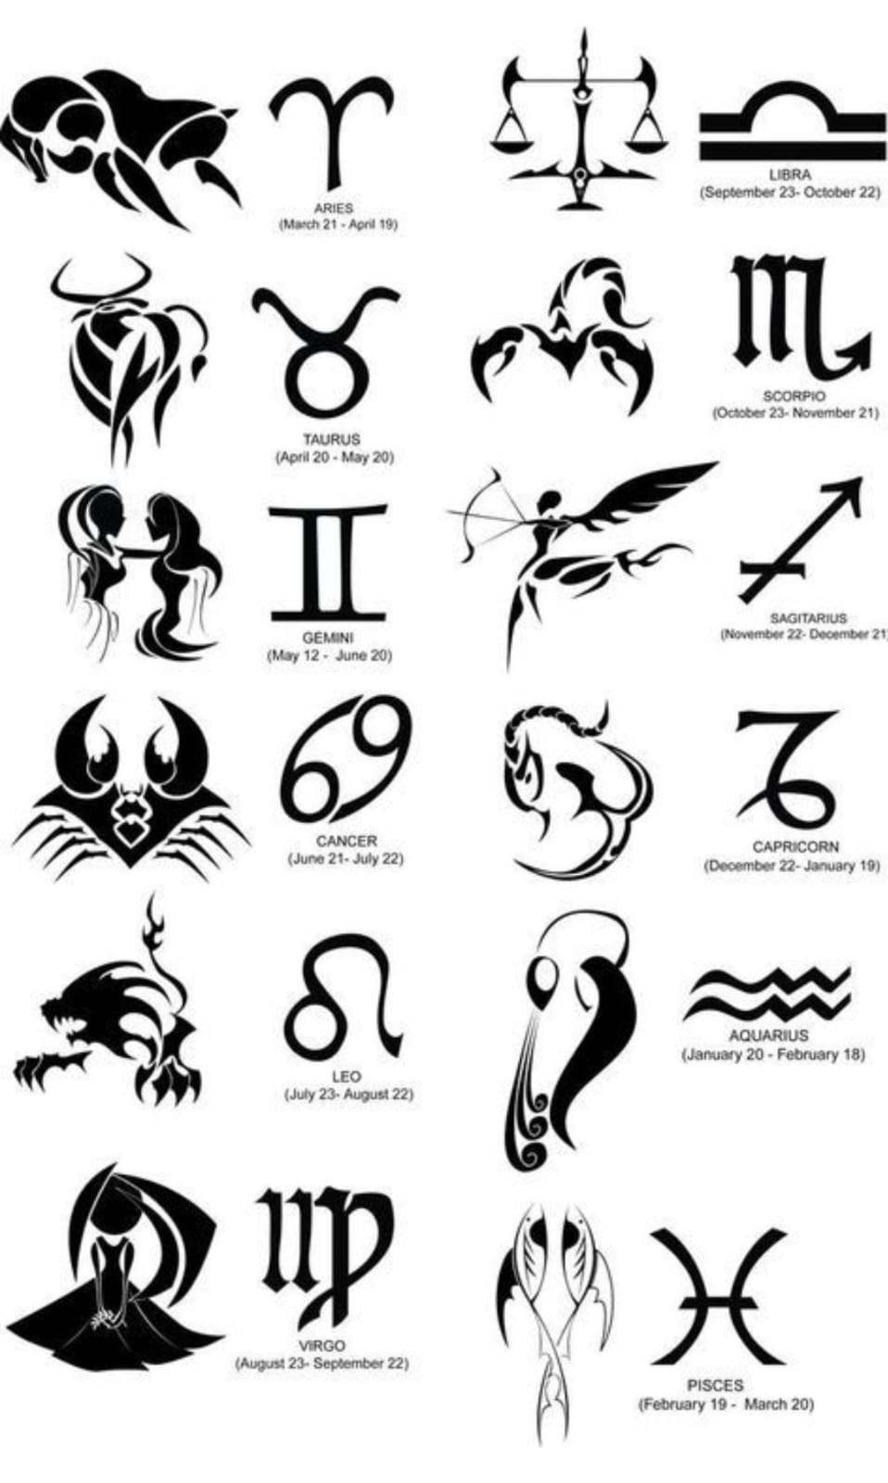

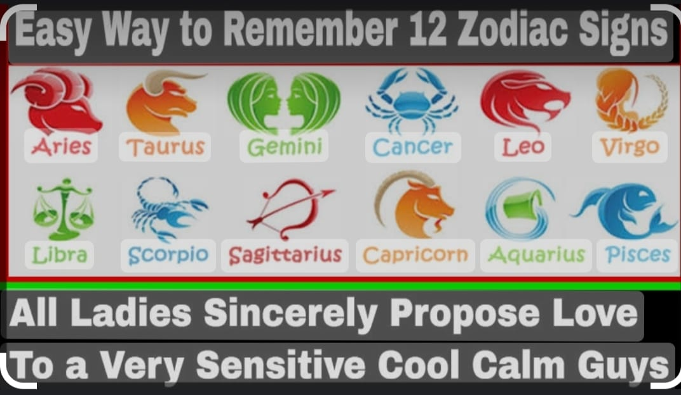

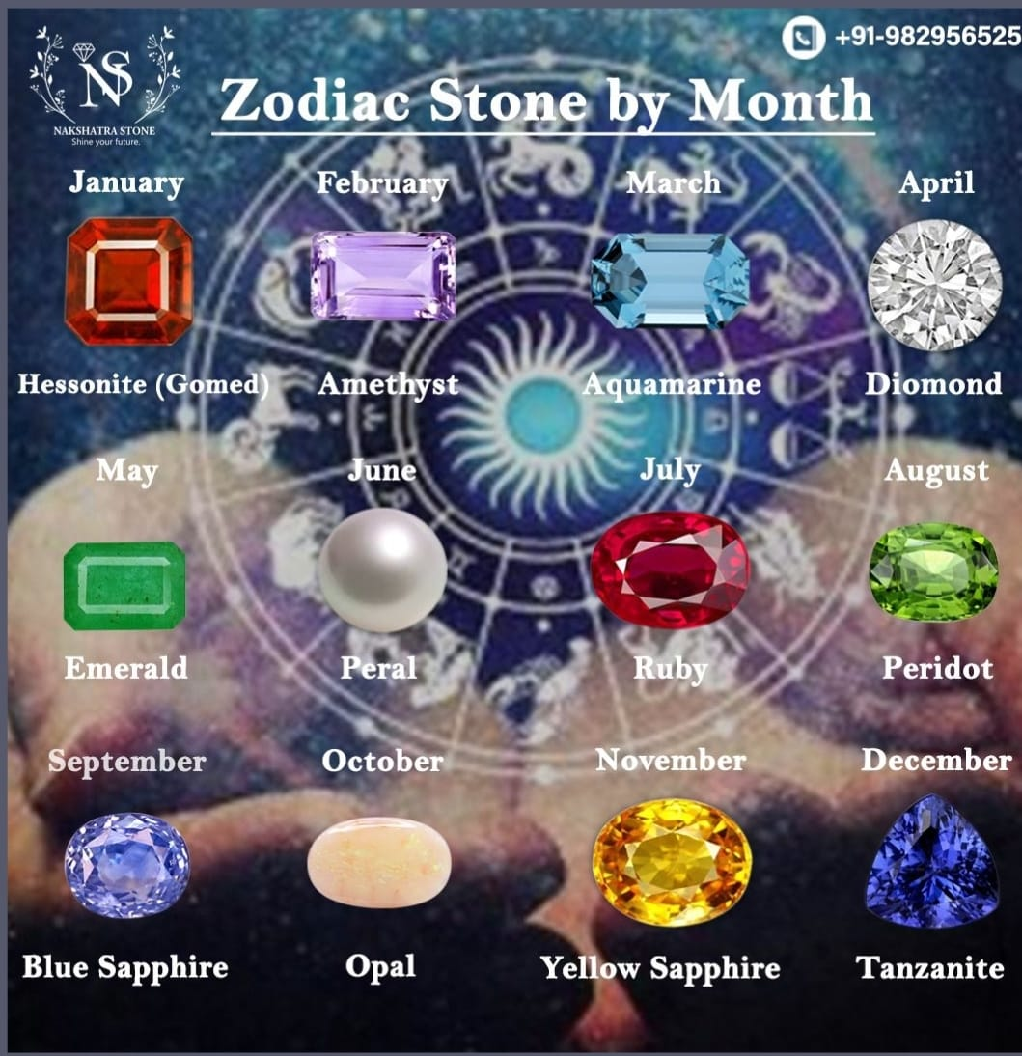

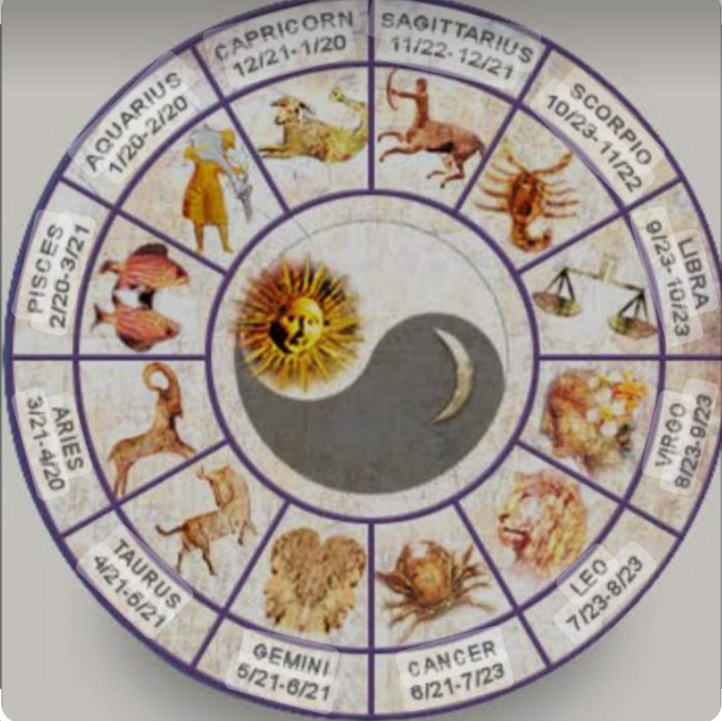

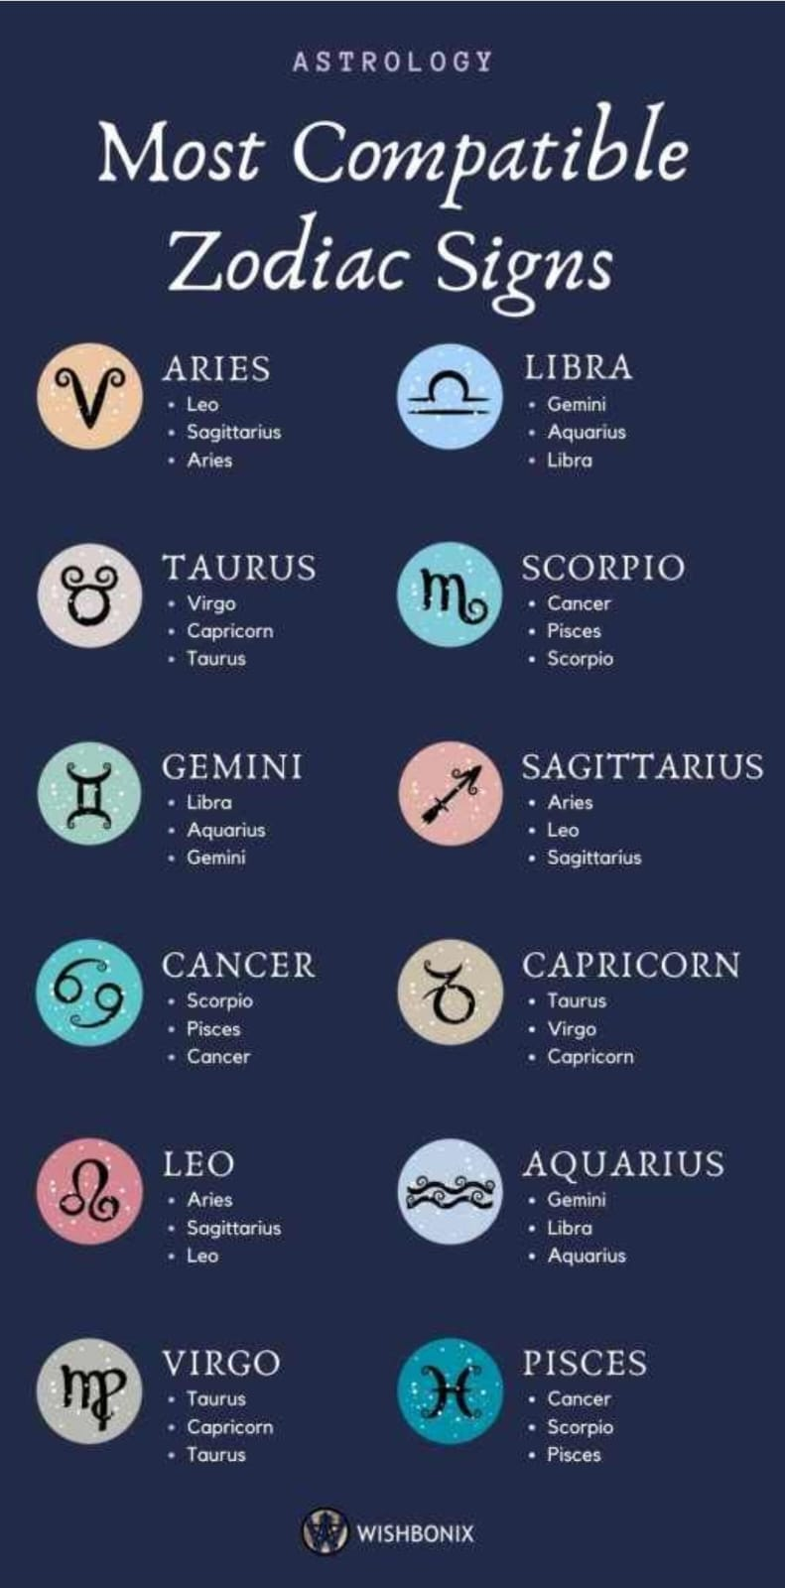

**12. DAMRO**

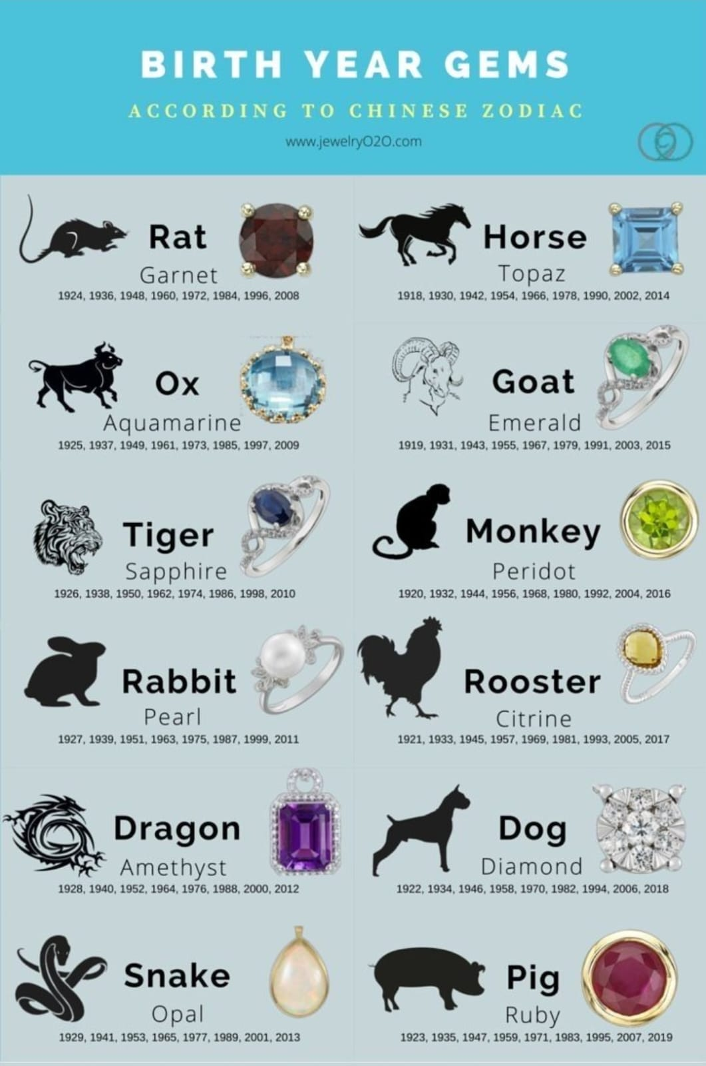

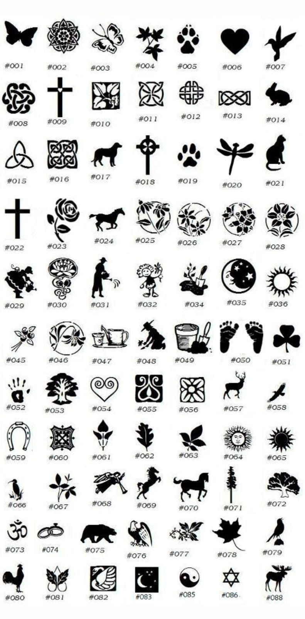

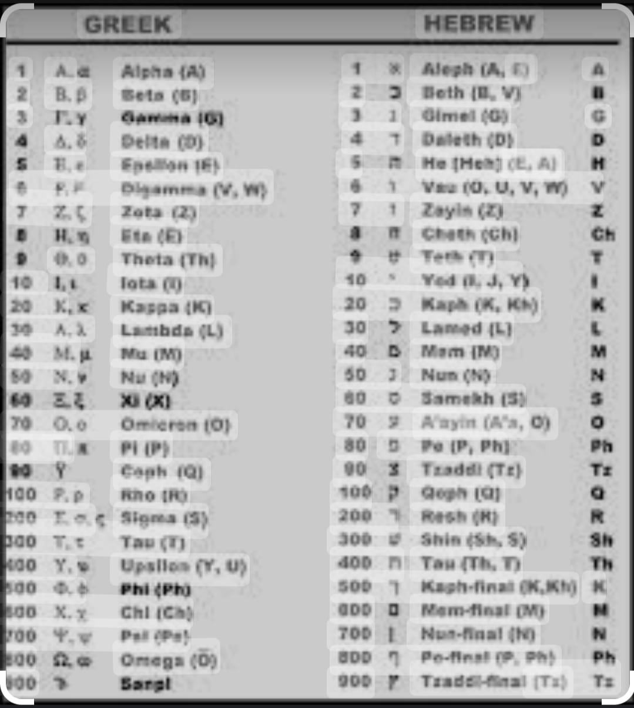

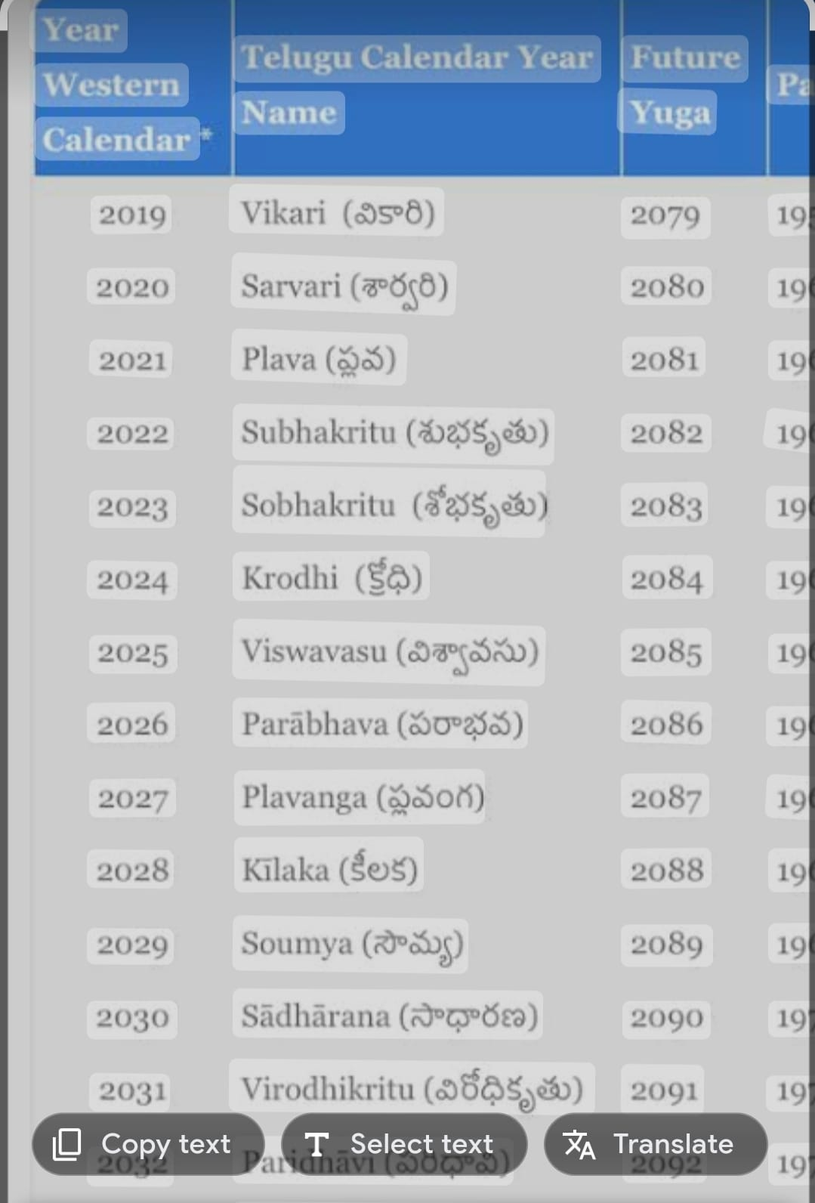

|  |  |  |  |  |  |  |  |
| --- | --- | --- | --- | --- | --- | --- | --- |
| **Year** | **Ayanamsa:** | **Year** | **Ayanamsa:** | **Year** | **Ayanamsa:** | **Year** | **anamsa** |
|  | D-M-S |  | D-M-S |  | D-M-S |  | D-M-S |
| 1900 | 22-22-30 | 1939 | 22-55-10 | 1978 | 23-27-49 | 2017 | 24-00-30 |
| 1901 | 22-23-20 | 1940 | 22-56-00 | 1979 | 23-28-40 | 2018 | 24-01-2020 |
| 1902 | 22-24-11 | 1941 | 22-56-50 | 1980 | 23-29-30 | 2019 | 24-02-2010 |
| 1903 | 22-25-01 | 1942 | 22-57-40 | 1981 | 23-30-20 | 2020 | 24-03-2000 |
| 1904 | 22-25-51 | 1943 | 22-58-31 | 1982 | 23-31-10 | 2021 | 24-03-1951 |
| 1905 | 22-26-41 | 1944 | 22-59-21 | 1983 | 23-32-01 | 2022 | 24-04-1941 |
| 1906 | 22-27-32 | 1945 | 23-00-11 | 1984 | 23-32-51 | 2023 | 24-05-1931 |
| 1907 | 22-28-22 | 1946 | 23-01-2001 | 1985 | 23-33-41 | 2024 | 24-06-2021 |
| 1908 | 22-29-12 | 1947 | 23-01-1952 | 1986 | 23-34-31 | 2025 | 24-07-2012 |
| 1909 | 22-30-02 | 1948 | 23-02-1942 | 1987 | 23-35-22 | 2026 | 24-08-2002 |
| 1910 | 22-30-53 | 1949 | 23-03-1932 | 1988 | 23-36-12 | 2027 | 24-08-1952 |
| 1911 | 22-31-43 | 1950 | 23-04-2022 | 1989 | 23-37-02 | 2028 | 24-09-1943 |
| 1912 | 22-32-33 | 1951 | 23-05-2013 | 1990 | 23-37-53 | 2029 | 24-10-1933 |
| 1913 | 22-33-23 | 1952 | 23-06-2003 | 1991 | 23-38-43 | 2030 | 24-11-2023 |
| 1914 | 22-34-13 | 1953 | 23-06-1953 | 1992 | 23-39-33 | 2031 | 24-12-2013 |
| 1915 | 22-35-04 | 1954 | 23-07-1943 | 1993 | 23-40-2 | 2032 | 24-13-04 |
| 1916 | 22-35-54 | 1955 | 23-08-1934 | 1994 | 23-41-14 | 2033 | 24-13-54 |
| 1917 | 22-36-44 | 1956 | 23-09-2024 | 1995 | 23-42-04 | 2034 | 24-14-44 |
| 1918 | 22-37-34 | 1957 | 23-10-2014 | 1996 | 23-42-54 | 2035 | 24-15-34 |
| 1919 | 22-38-25 | 1958 | 23-11-2004 | 1997 | 23-43-44 | 2036 | 24-16-25 |
| 1920 | 22-39-15 | 1959 | 23-11-1955 | 1998 | 23-44-35 | 2037 | 24-17-15 |
| 1921 | 22-40-05 | 1960 | 23-12-1945 | 1999 | 23-45-25 | 2038 | 24-18-05 |
| 1922 | 22-40-55 | 1961 | 23-13-35 | 2000 | 23-46-15 | 2039 | 24-18-55 |
| 1923 | 22-41-46 | 1962 | 23-14-25 | 2001 | 23-47-05 | 2040 | 24-19-46 |
| 1924 | 22-42-36 | 1963 | 23-15-16 | 2002 | 23-47-56 | 2041 | 24-20-36 |
| 1925 | 22-43-26 | 1964 | 23-16-06 | 2003 | 23-48-46 | 2042 | 24-21-26 |
| 1926 | 22-44-16 | 1965 | 23-16-56 | 2004 | 23-49-36 | 2043 | 24-22-17 |
| 1927 | 22-45-07 | 1966 | 23-17-46 | 2005 | 23-50-26 | 2044 | 24-23-07 |
| 1928 | 22-45-57 | 1967 | 23-18-37 | 2006 | 23-51-17 | 2045 | 24-23-57 |
| 1929 | 22-46-47 | 1968 | 23-19-27 | 2007 | 23-52-07 | 2046 | 24-24-47 |
| 1930 | 22-47-37 | 1969 | 23-20-17 | 2008 | 23-52-57 | 2047 | 24-25-38 |
| 1931 | 22-48-28 | 1970 | 23-21-07 | 2009 | 23-53-47 | 2048 | 24-26-28 |
| 1932 | 22-49-18 | 1971 | 23-21-58 | 2010 | 23-54-38 | 2049 | 24-27-18 |
| 1933 | 22-50-08 | 1972 | 23-22-48 | 2011 | 23-55-28 | 2050 | 24-28-08 |
| 1934 | 22-50-58 | 1973 | 23-23-38 | 2012 | 23-56-18 | 2051 | 24-28-59 |
| 1935 | 22-51-49 | 1974 | 23-24-28 | 2013 | 23-57-09 | 2052 | 24-29-49 |
| 1936 | 22-52-39 | 1975 | 23-25-19 | 2014 | 23-57-59 |  |  |
| 1937 | 22-53-29 | 1976 | 23-26-09 | 2015 | 23-58-49 |  |  |

Yours Truly Dharma Saviour Adharma Slaughterer Always Anyways Keenu Reeves KVSCS76 BB MJ76 && KVHR55 King God Father KVHR.JR KVBB 88 100% PAKKA

🦁ParadhiMaan Padayappa🦁

🕉Total Completed DURING 10.11 IST ON 28/08/2022 – 04:45 IST ON 20/09/2022 – 16:08 IST ON 21/09/2022

For the sake of Mega Human Population Total Improvisation from your DAVIDSOLOMONDUKESDAD DR.VishnuVardhanBharatBhushan KV The Great

"Fourteen lokas

bhu, bhuvas, svar, mahas, janas, tapas, and satya above DIVYA LOKAS ABHAY JAY ABHIRAM MY Recharge Mate 4m SASTRA University JAI SRI KRISHNA Alias ALLAHU AKBAR The Greatest King Erraro Pharaoh Akhenaten Amenhotep VI King is Singh Singh is King of RPS Rakul Preet Singh MASHOOKA Song also Plays Your Honour Respected Supreme Court Judges I am your Beloved KALKI LION KING JUSTICE CHOWDARY RAO GARU and atala, vitala, sutala, rasātala, talātala, mahātala, pātāla and naraka ATHAMA LOKAS DIGVIJAY KRISHNA BHAYYA SAI BHABHA Kaveri Veera Bharat Bhushan KVBB KVHR.JR at the bottom."

🥳😚🤠😁😍🤩☺️🦹‍♂️🦁🫅👑🫅👑🫅👑...Ha ha ha Via Pole Star KVDhiruVPSQK 👨‍🎤👩‍🎤✴️🤩✡️🌟⭐💫🌇🌲🌠🌃🌉🌝🌛🌜🌚🌞🌤️🌦️🌥️⛱️☪️🧜‍♂️🧜💭🌟⭐️🌊🗯🌈🔥💫🌍✈️🤑🔯✡️😝🕉️